**DOKIMI: A Quantitative Classification for Students Taking Up PRE-Test & POST-Test of the National Career Admission Examination (NCAE)**

**Yangco, Tristan Josh D.**

Cebu Institute of

Technology-University  
N. Bacalso Avenue  
Cebu City 6000  
09359328453

tristanjosh.yangco@cit.edu

**Siton, Kenneth James P.**

Cebu Institute of

Technology-University

N. Bacalso Avenue

Cebu City 6000

09999675585

kennethjames.siton@cit.edu

**Tabuno, Jules Nicolson E.**

Cebu Institute of

Technology-University  
N. Bacalso Avenue  
Cebu City 6000  
09226595876

julesnicolson.tabuno@cit.edu

**Maspiñas, Kian Alexander C.**

Cebu Institute of

Technology-University

N. Bacalso Avenue

Cebu City 6000

09286210062

kianalexander.maspinas@cit.edu

**Ofianga, John Kendrick K.**

Cebu Institute of

Technology-University  
N. Bacalso Avenue  
Cebu City 6000

09950076548

johnkendrick.ofianga@cit.edu

**ABSTRACT**

**CCS Concepts**

• **Data Analytics, Applied Computing, Web Development, Web Application, Platform as a Service (PaaS), Cloud Platform, Quasi-Experimental Research**

**Keywords**

Pre-NCAE; post-NCAE; Student; Adviser; Classroom; Grade 9; Junior High; data analytics; predictive analysis; National Career Admission Examination (NCAE); learning gain; Class average normalized gain; fields of interest; STEM; HUMSS; ABM; GAS; Tec-Voc; Python; Django; PostgreSQL; MVC; SUS; Likert Scale; Quasi-Experimental

**1. INTRODUCTION**

In the Philippines' new curriculum sanctioned by the Department of Education (DepEd), Secondary Education, specifically High School was added 2 years when Secondary Education in the Philippines was divided into two parts the Junior High School (Grade 7 - 10) and Senior High School (Grade 11-12) as per the K to 12 Program mandates. A program for career assessment will be administered through National Career Admission Examination (NCAE) when a student reaches Grade 9 (Ferrer & Dela Cruz, 2017). Its goal is to provide high-quality education through regulation and monitor the flow of high school graduates to the strands where they have better aptitude or potential (Escudero, 2016). However, before taking the actual examination, students will undergo a series of dry-run tests like pre-NCAE and post-NCAE to test the integrity of the students in answering the exam, and simulate the official NCAE environment.

Senior High School is composed of different academic tracks namely: Science, Technology, Engineering and Mathematics (STEM); Humanities, and Social Sciences (HUMSS), Accountancy, Business and Management (ABM); and Technical and Vocational (Tec-Voc). (Tan, 2018).

In this study, pre-NCAE and post-NCAE will be the scope of this research to provide richer insights for the teachers on how the students perform during the NCAE and determine their future strand in Senior High School by determining the learning gain between pre-NCAE and post-NCAE scores, and the highest rating of the students' areas of occupational interest.

**2. REVIEW OF RELATED SOFTWARE**

This section contains applications that share aspects in common with the study. The research is compared to the associated software to see where the parallels and differences are.

**2.1 Synap**

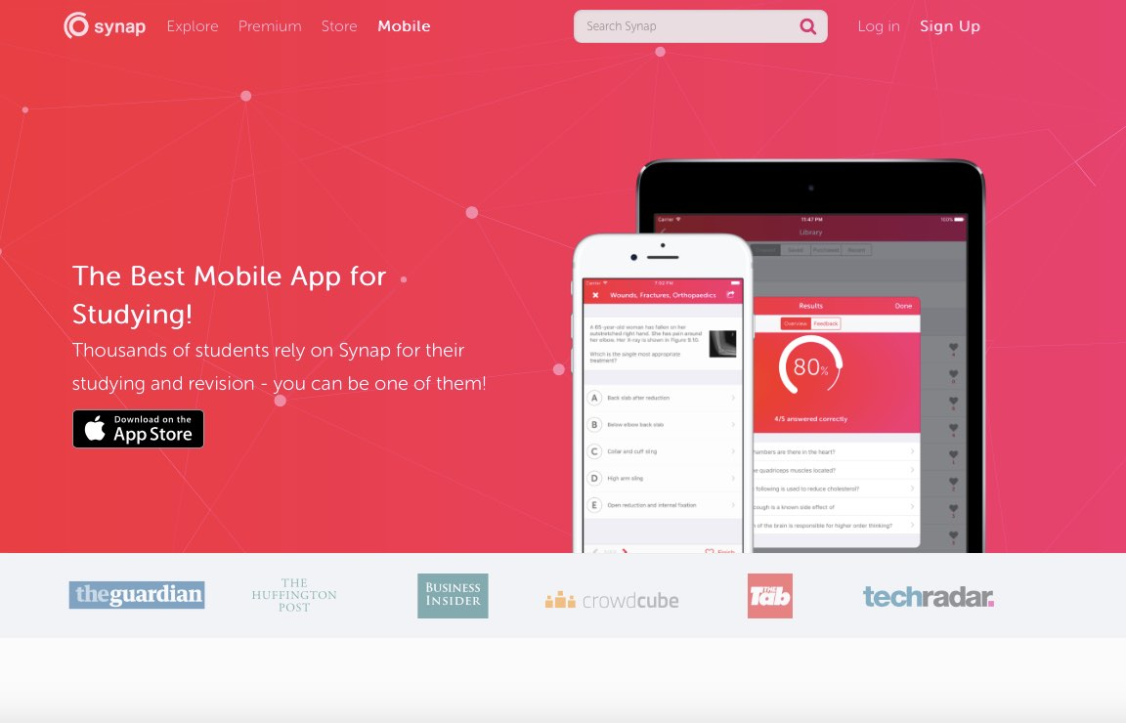

**Figure 1. Synap Main Web Page**

Synap is an all-in-one exam preparation and live exam platform. Create, organize, and administer highly customized assessments using a variety of question types such as image-based questions and answers, MCQs, and EMQs, among others. Choose between immediate and delayed feedback for your test takers, as well as detailed learner reports that show which topics and questions your students excelled in.

**2.2 FlexiQuiz**

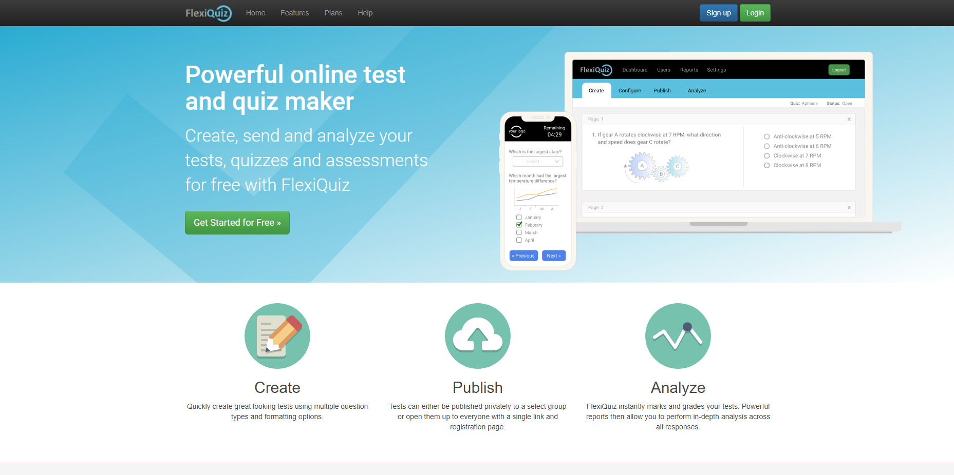

**Figure 2. FlexiQuiz Main Web Page**

FlexiQuiz is a quiz and assessment generator that allows users to design unique assessments for employees, clients, or students. The assessments can be made private so that only a few people can access them, or they can be made public so that anybody can take them. They are scored automatically by the software.

FlexiQuiz is designed to be simple to use, with hundreds of configurable options to allow anyone to build engaging exams, quizzes, or courses rapidly. Time restrictions, progress bars, question banks, certificates, notifications, and the ability to add logos, photos, videos, or music to quizzes are all available on the platform. Password-protected content can be shared publicly or privately.

**2.3 TestGorilla**

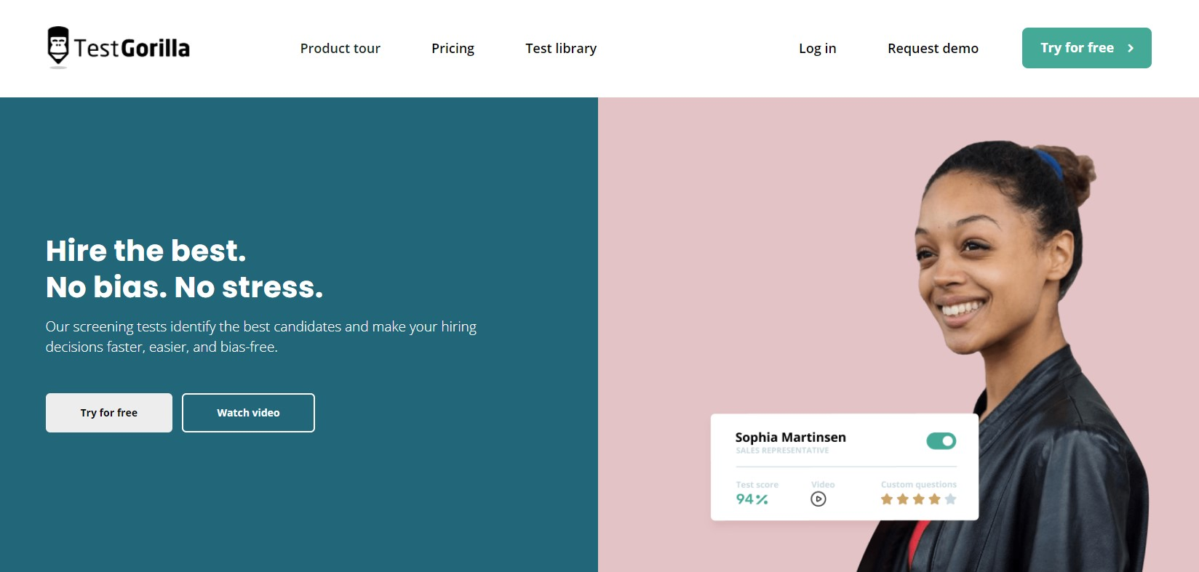

**Figure 3. TestGorilla Main Web Page**

TestGorilla is a pre-employment testing program that helps companies manage the entire hiring process, from developing assessments and inviting candidates to conduct a thorough analysis of the findings. Businesses can also rank or sort applicants using ratings, alphabetical order, recent actions, or responses, and analyze them using performance reports and test results.

Following the testing, the user may examine the results using TestGorilla’s user-friendly and comprehensive reports. All of this allows the user to properly anticipate their candidates' work success in the actual world.

**2.4 YouTestMe GetCertified**

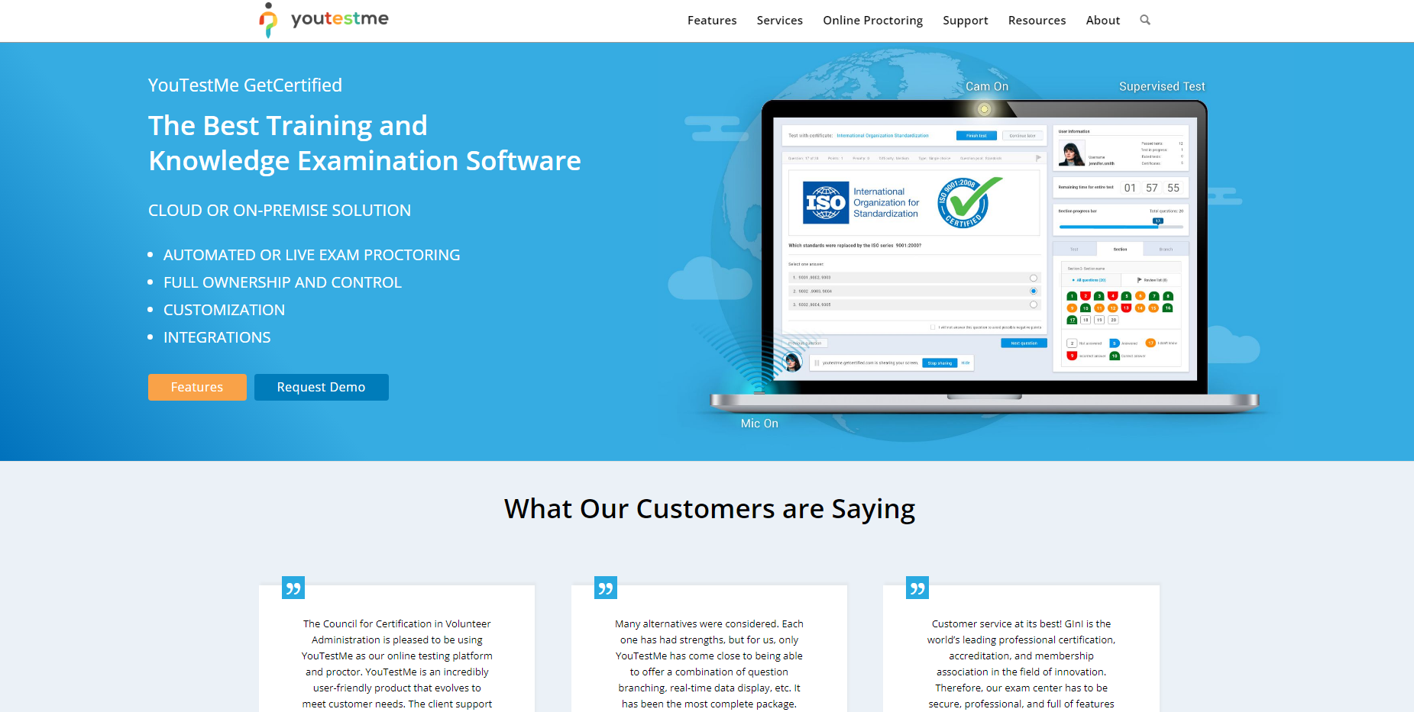

**Figure 4. YouTestMe GetCertified Main Web Page**

YouTestMe GetCertified is an online examination and certification solution that includes automated test and answer generators, a certificate designer, customisable branding, and a variety of third-party connectors.

YouTestMe GetCertified groups questions into question pools, which are initially only visible to the creator but can be shared with others. There are eight different sorts of questions, and users can choose the frequency, complexity, and points or penalties for each one. Users can add pictures to questions and answers, and questions can be imported from Excel files.

**2.5 Khan Academy**

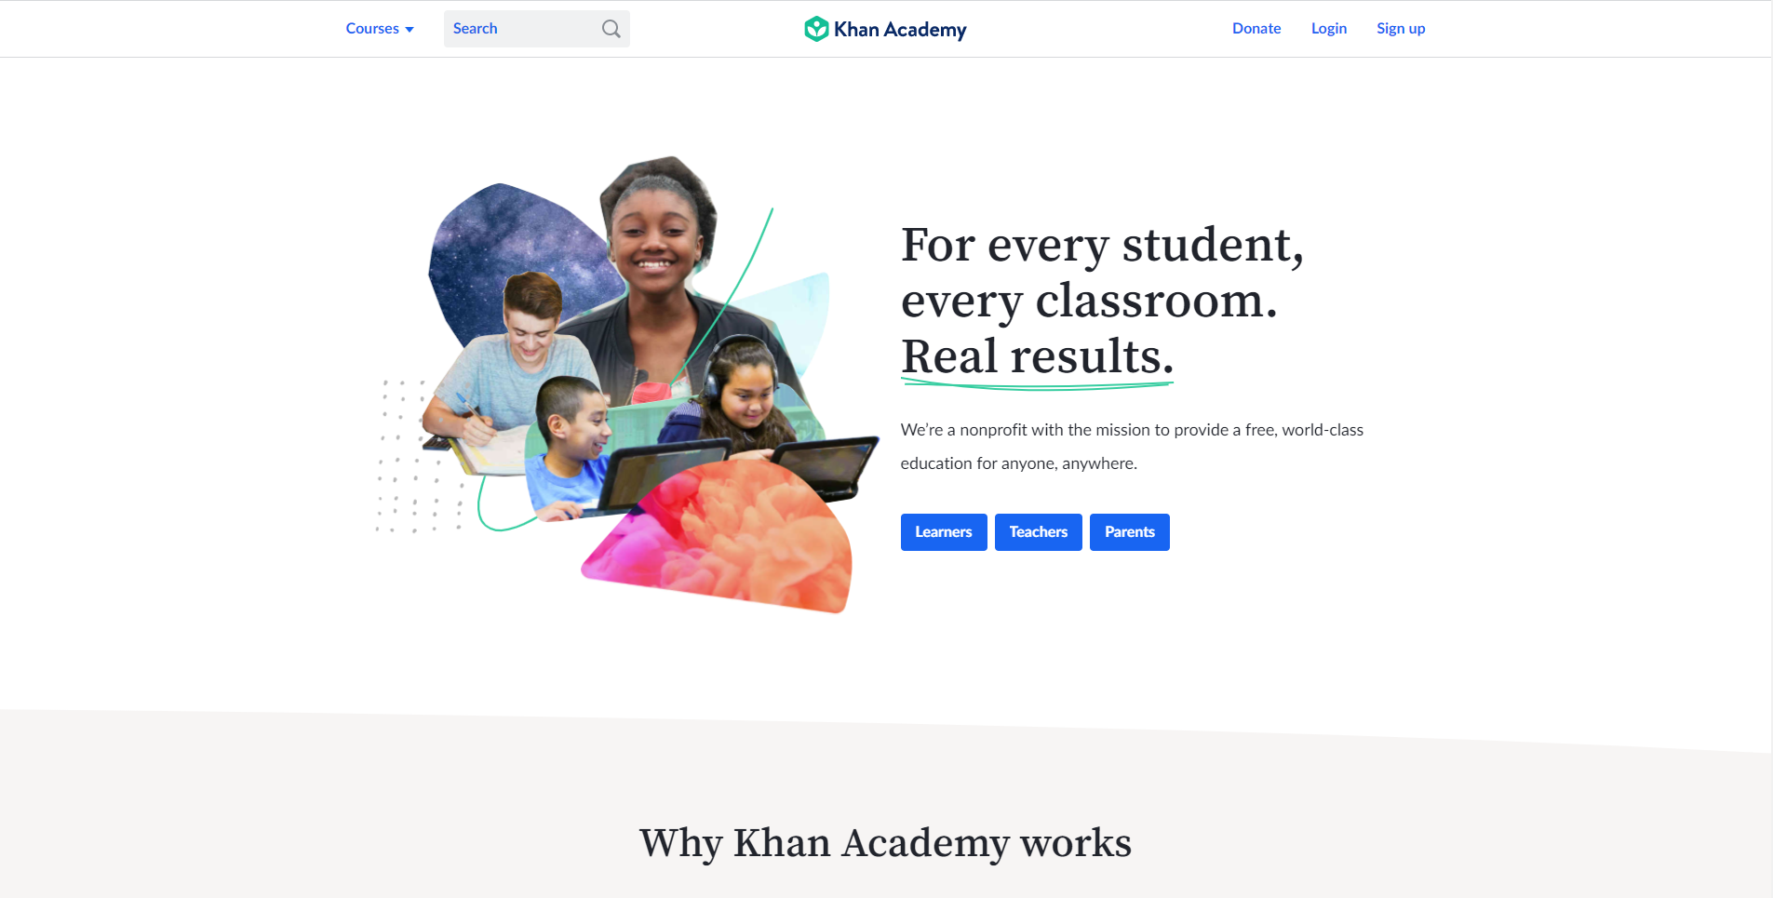

**Figure 5. Khan Academy Main Web Page**

A section of the Khan Academy SAT prep website is available through the Khan Academy SAT prep app. Because the Khan Academy is a College Board partner, the Khan Academy app has been designated as the official SAT prep app. The NCAE and SAT tests are similar, yet they serve different purposes.

Khan Academy offers practice exercises, instructional videos, and a personalized learning dashboard that empower learners to study at their own pace in and outside the classroom. It focuses on skill mastery to help learners establish strong foundations, so there's no limit to what they can learn next.

**2.6 Fresherslive**

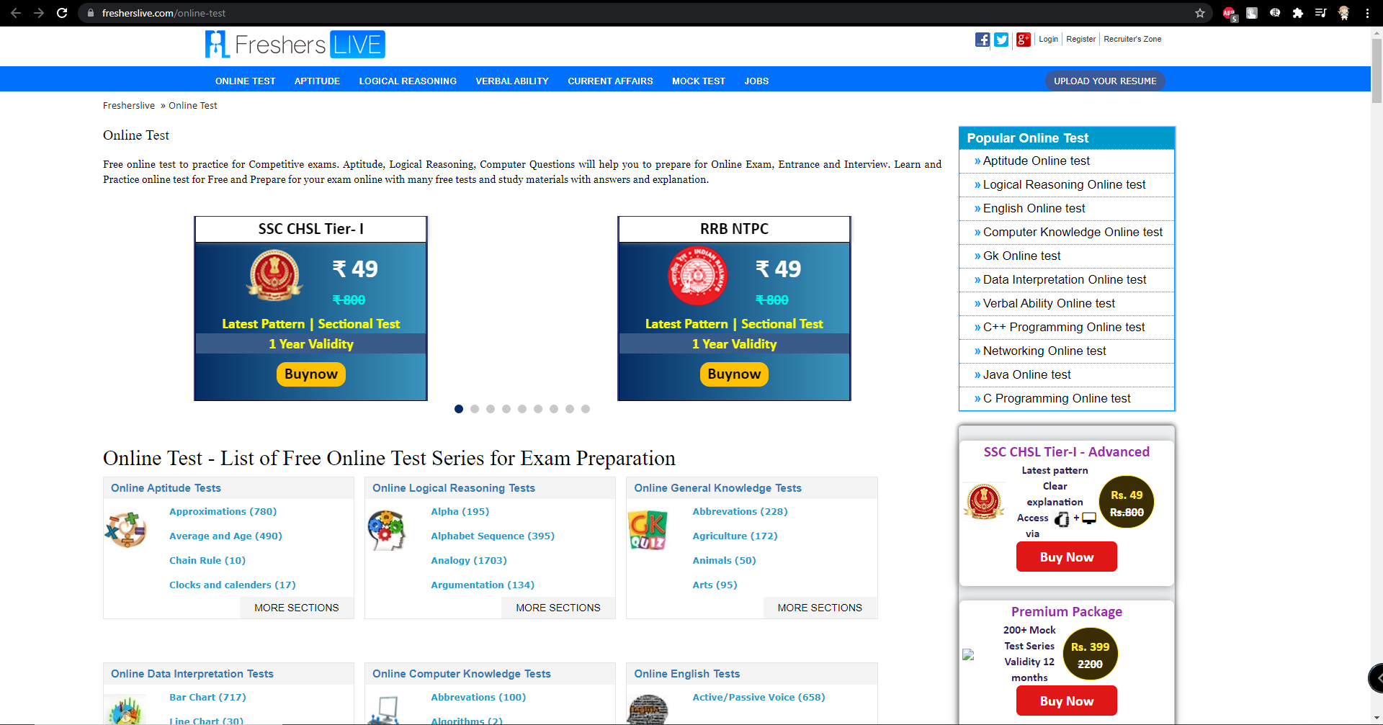

**Figure 6. fresherslive Main Web Page**

Fresherslive is a leading Job site for Freshers who seek employment opportunities in both Private and Government sectors in India. Established in 2009, Fresherslive has helped more than 100,000 candidates get their first job in leading companies across India.

Practice for competitive examinations with a free online test. Aptitude, Logical Reasoning, and Computer Questions will aid you in your preparation for the Online Exam, Entrance Exam, and Interview. Learn and practice online tests for free, and study for your exam with a variety of free exams and study materials that include answers and explanations.

**2.7 Class Marker**

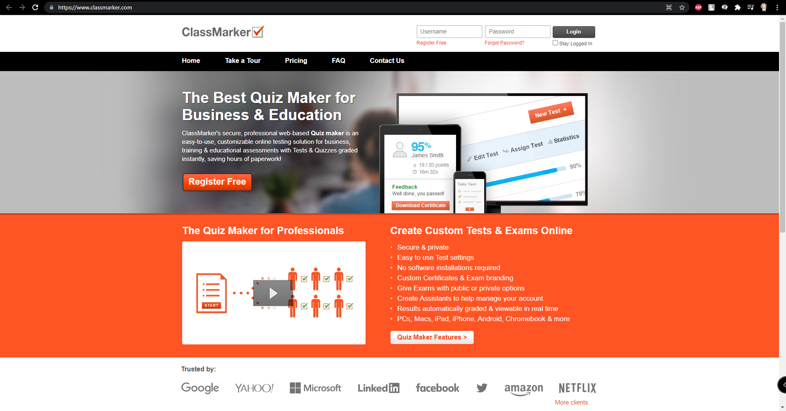

**Figure 7. Class Marker Main Web Page**

For both teachers and businesses in 2021, ClassMarker's hosted Online Testing software delivers the greatest Quiz creation tool. Used for business & enterprise training tests, pre-employment assessments, online certifications & compliance, recruitment, health & safety quizzes, schools, universities, distance learning, lead generation, GDPR & CCPA compliance, online courses, E-Learning, practice Tests, and more around the world.

Every firm can benefit from our low-cost Online Testing Plans. ClassMarker is your secure and trustworthy exam maker and online testing solution for everything from occasional testing to enterprise quiz maker needs. With ClassMarker, you can also test thousands of users at once.

**2.8 QuestBase**

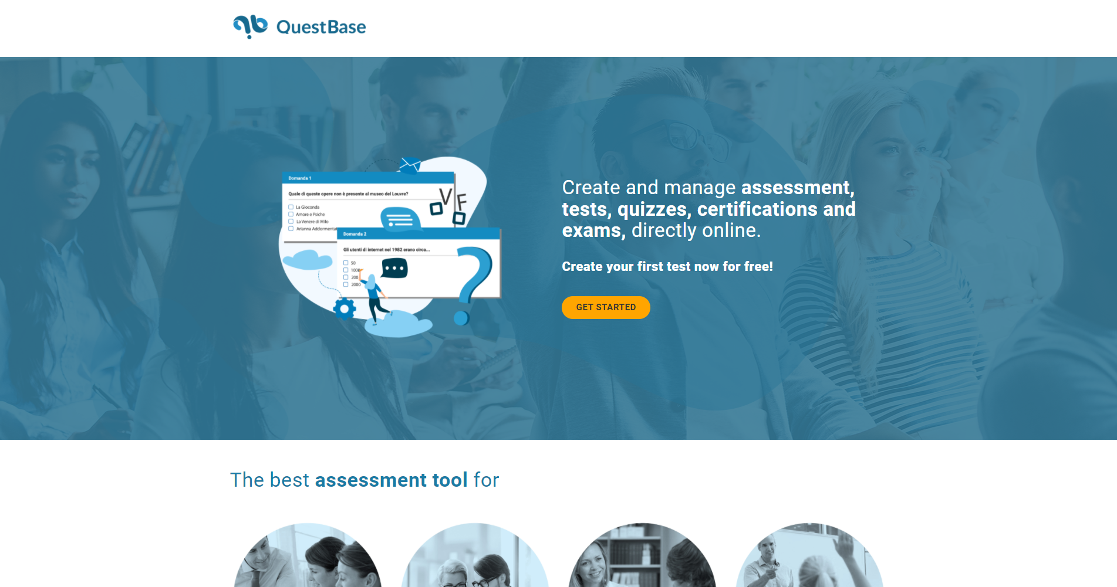

**Figure 8. QuestBase Main Web Page**

QuestBase Exam Software is a web-based secure platform for exam test services. The software is widely used across schools, online teaching courses, e-learning portals, mock test sessions and many more. They provide a cloud supported solution for major exam-related questions and tests. QuestBase pricing offers instant exam solutions for educational organizations, non-profit enterprises, and businesses SMEs, and agencies.

QuestBase Exam Software is a Saas tool that helps to build exam tests, quizzes, and deliver assignments for the teachers and trainers. It is designed for the training and learning process that prepares question banks, adds security features and develops personalized certificates. It offers solutions for both online and printed learning methods. The solution is also used for business and training projects, hiring mechanisms, and educational programs.

**2.9 College Entrance Exams Prep - VITEEE NIFT JNUCEE**

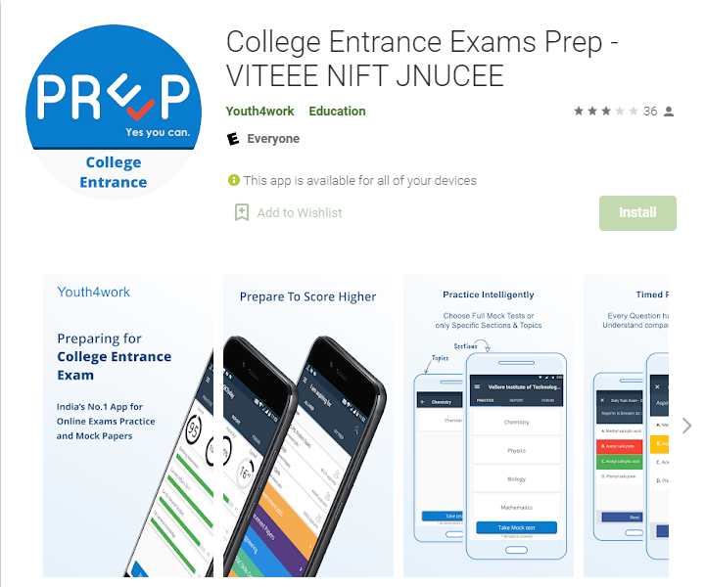

**Figure 9. College Entrance Exam Main Web Page**

College Entrance Exams Prep aka The Best Online Prep Test Series is an online platform brought by Youth4Work.com that employs innovative data analytics to assist students in preparation for their college exams, improving their preparation, and progressing in their careers.

Mock Tests covering questions from all topics for the college entrance test, Reports reflecting score, accuracy, and speed, which help you know where you stand and track your progress, and Discussion Forums to keep you connected with other Aspirants and keep you informed about exams are some of the App's unique features.

**2.10 USATestprep: K-12**

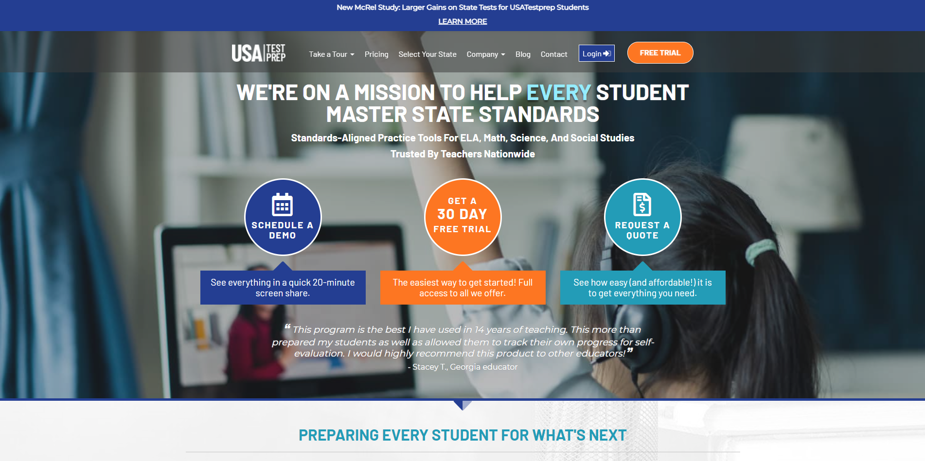

**Figure 10. USATestprep Main Web Page**

USATestprep, LLC is recognized as a nationwide leader in curriculum resources and test preparation for high schools, middle schools, and elementary schools.

USATestprep's approach is designed to help the teacher help the students. Whether we're writing questions to assess a specific state standard, making a reporting feature that helps teachers identify student weaknesses, or adding a new game that gets students excited about using the site, we always take great care to ensure that each new feature engages the students and is easy to implement by the teacher.

**2.11 Matrix of Comparison**

The table below shows the matrix of comparison. The matrix of comparison compares which features are present or missing in a particular application. This will provide a quick visualization of the advantages between the reviewed related software.

| Features | Dokimi | Synap | FlexiQuiz | TestGorilla | YouTestMe |
| --- | --- | --- | --- | --- | --- |
| Dynamic Test Timer per aptitude | ✔ | ✔ | x | x | ✔ |
| Mobile Access | x | ✔ | x | ✔ | x |
| Reporting/Analytics | ✔ | ✔ | ✔ | ✔ | ✔ |
| Pre-Test/Post-Test Examination | ✔ | x | x | x | x |

| Features | Khan Academy | Fresherslive | Class Marker | College Entrance Exams Prep | USATesprep: K-12 | QuestBase |
| --- | --- | --- | --- | --- | --- | --- |
| Dynamic Test Timer per aptitude | x | x | ✔ | x | x | ✔ |
| Mobile Access | ✔ | x | ✔ | ✔ | x | x |
| Reporting/Analytics | ✔ | x | ✔ | ✔ | ✔ | ✔ |
| Pre-Test/Post-Test Examination | x | x | x | x | x | x |

**Table 1: Matrix of Comparison (Compare Dokimi with other applications)**

**3. METHODOLOGY**

This is the methodology section of the study where discussions relevant to the formulation of ideas, towards the creation of this study. Feature Driven Development (FDD) method will be used for the researchers involved in this study to maximize client-centric approach. Web development using Django Framework will be utilized to simulate NCAE Examination, and extract data in a csv format to run predictive analytics. Further details will be discussed in the later sections of this study.

**3.1 Observation**

The National Career Admission Examination (NCAE) was taken by the researchers throughout their Grade 9 days. Before taking the real NCAE, the researchers noticed that their class counselors would conduct a pre-test and post-test NCAE Examination to verify the exam's efficacy and students' honesty in answering the questions. However, class advisers only look into the effectiveness and integrity, but not on the student’s learning gain, and their possible career based on their test scores. Choosing a career is a never-ending process, since experimentation, trial and error, decision-making, and finally judgment are all part of the process of choosing a career. (Cardinas, et.al., 2020). The researchers were able to identify the recurring problems in Grade 9 students as they had direct experience taking the pre- and post-test NCAE Exam. The researchers saw a need for enhancements, particularly in emulating the actual NCAE Exam, so that Grade 9 students see NCAE as a valuable tool in leading them toward their intended career.

**3.2 Assumption**

The researchers believed that historical data from last year's pre-test and post-test results must be collected with the consent of the Grade 9 advisers who facilitated the NCAE pre-test and post-test exams because this study is believed to be dependent on the student's data, particularly the pre-test and post-test scores, and their chosen profession. The researchers will next conduct data analysis on the pre-test and post-test findings to identify the students' learning gains, as well as a prospective Senior High School Track depending on their chosen career and pre-test and post-test performance. The researchers believe that creating a simulation will be an alternative solution, in which Grade 9 students will use the researchers' simulation application to answer our pre-test and post-test, and then the researchers will collect the answers and results in a database, extract the database, and convert it to a Comma-separated values (csv) format, where they will run an analysis, observe the results, and draw conclusions. These solutions will improve the National Career Admission Examination (NCAE) pre-test and post-test, where advisers will not only monitor students' integrity in answering the exam, but will also provide insights into their learning gains, predicted Senior High School Track based on their performance, and chosen profession in the pre-test and post-test results.

**3.3 Methodological Approach**

This section contains the information about the surveys that will be used to complement the user's perceptions in order to discover the user's wants and pain spots for the simulation application.

*3.3.1 Research Instrument*

The researchers formulated a survey consisting of simple Yes or No Questions and Rate Questions using Google Forms. These questions are meant to gather opinions to improve user experience.

**Table 2. Survey Questionnaire**

| **No.** | **Question** | **Type** |
| --- | --- | --- |
| **1** | Do you wish to take the exam on NCAE without taking the real NCAE? | Yes/No |
| **2** | Would you like to have a timer when taking the exams? | Yes/No |
| **3** | Would you like to have your results immediately after taking the exams? | Yes/No |
| **4** | Should you base your career path from what the results have given you? | Yes/No |
| **5** | Is it mandatory to take the NCAE? | Yes/No |
| **6** | Would creating an online software of NCAE make a difference from what it usually does? | Yes/No |
| **7** | Do you take it seriously when taking the NCAE exam? | Yes/No |
| **8** | Should we use the data from DepEd to make the system certifiable? | Yes/No |
| **9** | Should everyone follow the result of the NCAE in their careers? | Yes/No |
| **10** | On a scale of 1-5, rate the accuracy of the NCAE result you had last. |  |

**Table 2: Dokimi Survey Questionnaire (Compare Dokimi with other applications)**

*3.3.2. Research Respondents*

The respondents for this research will be the Junior High School Students, particularly the Grade 9 Students in Cebu Institute of Technology University to fit in the standards as mentioned in this study where the National Career Admission Exam (NCAE) will be designed for Grade 9 Students.

*3.3.3. Research Design*

The researchers gather data from the respondents that is interpreted and evaluated using descriptive statistics. The collected data was processed by converting verbal responses to numeric equivalents in some instances. The data were then represented in graphs and translated into numerical ratios with the use of Microsoft Excel analytics.

**3.4. System Formation**

The researchers reviewed the future stages of the study once more after completing the survey questions in the Research Instrument section. The researchers then constructed architectures, designs, and data flows based on the questionnaire, which will provide them with the baseline aspects of what Dokimi will look like and how it will perform. The researchers also planned on using Django Framework as a tool for Dokimi web development, and PostgreSQL to store Dokimi data within the PostgreSQL Repository, and researchers will then analyze the data once both Part I (Pre-test) and Part II (Post-test) are completed to calculate the learning gain per aptitude, and the average scores of Part I (Pre-test) and Part II (Post-test) to determine potential SHS Strand..

**3.5. System Design and Specification**

This section shows Model View Controller (MVC) Architecture of the project, its framework and the Unified Modeling Language (UML) diagrams of the system.

*3.5.1. MVC Architecture*

The Model-View-Controller (MVC) is an architectural model that divides an application into three logical components: model, view, and controller. Each of these components is designed to handle specific parts of application development. MVC is a popular industry-standard web development framework for developing scalable and flexible projects.

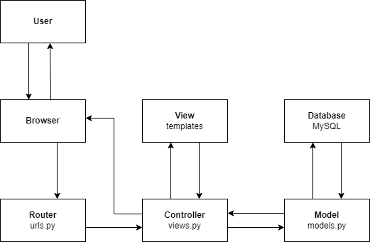

**Figure 11. MVC Architecture of DOKIMI**

Figure 11 shows the process of how the user receives/sends a request via browser. When the user sends a request via browser. The URL pattern and handler details are defined by the route and would send the request to the controller. The controller is in charge of the application logic and serves as a coordinator between the View and the Model. The Controller accepts user input through the View, processes the data with the help of Model, and then returns the results to the View. All data-related functionality that the user engages with is represented by the Model component. This can be the data being transmitted between the View and Controller components or any other data related to business logic.

*3.5.2. Frameworks and APIs*

To maximize data analytics utilities, Django Framework will be used to create the simulation application. This is an optimal framework for fast-paced and simpler development. This simulation application will mimic the written NCAE pre-test and post-test where the Grade 9 Students will first answer the Part I (pre-test) examination that is composed of Student Descriptive Questionnaire (SDQ), Part I proper (Reading Comprehension, Clerical Ability, Mathematical Ability, Visual Manipulative, Verbal Ability, Filipino, Scientific Ability, Logical Reasoning, Non-Verbal Ability, and Entrepreneurial Skills). After answering the Part I (Pre-test) of the examination, the results will be tabulated within the database (PostgreSQL). Part II (Post-test) will be available for simulation three days after the Part I (Pre-test) examination. After answering the Part II (Post-test), the results will be tabulated within the database (PostgreSQL), and the Dokimi itself will extract both Part I (Pre-test) and Part II (Post-test) for predictive analysis using equations from existing studies where the system will run an analysis that will determine the students’ learning gain between Part I (Pre-test) and Part II (Post-test), and the prospect Senior High School track based on the students’ performance in answering both part of the test, and the chosen profession within the Student Descriptive Questionnaire (SDQ).

*3.5.3 Use Case Diagram*

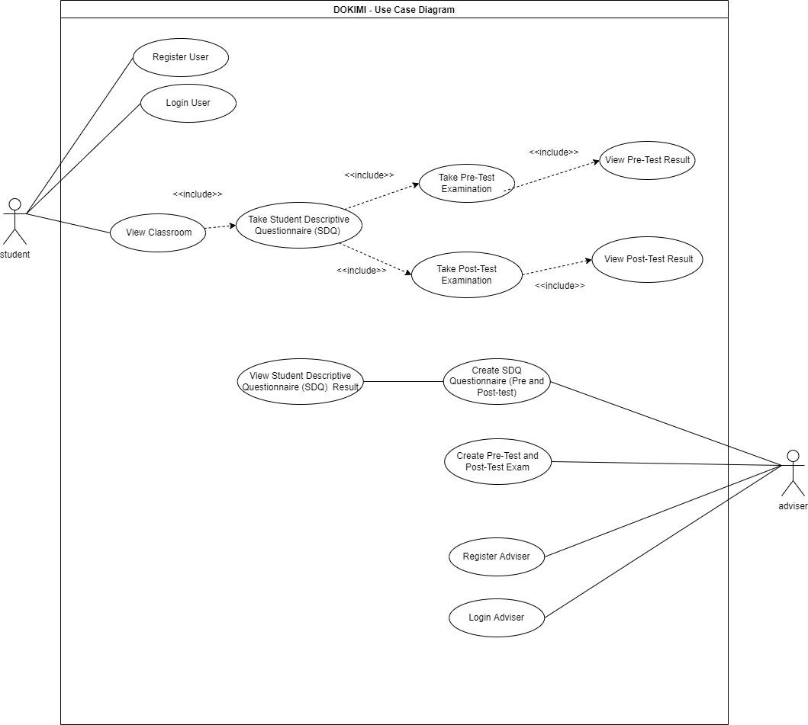

**Figure 12. Use Case Diagram involving Student, Adviser, and Administrator**

Figure 12 shows the Use Case Diagram for all users involved. Here, Students can Register and Login to Dokimi. Once the Students successfully Login and Register, Students will be redirected to the student dashboard where they can view the classroom they are assigned with. After entering the classroom, the students can now answer the Student Descriptive Questionnaire (SDQ), then the Part I (Pre-test). After three days, students can begin answering Part II (Post-test) of the exam. Once the exam is finished, Dokimi itself will extract the collected data from the PostgreSQL database, and start analyzing the data. The Advisers can Login and Register to Dokimi. After the Advisers successfully Login and Register, the Advisers can oversee the Students’ Student Descriptive Questionnaire (SDQ), Part I (Pre-test), and Part II (Post-test) of the exam.

*3.5.4. Class Diagram*

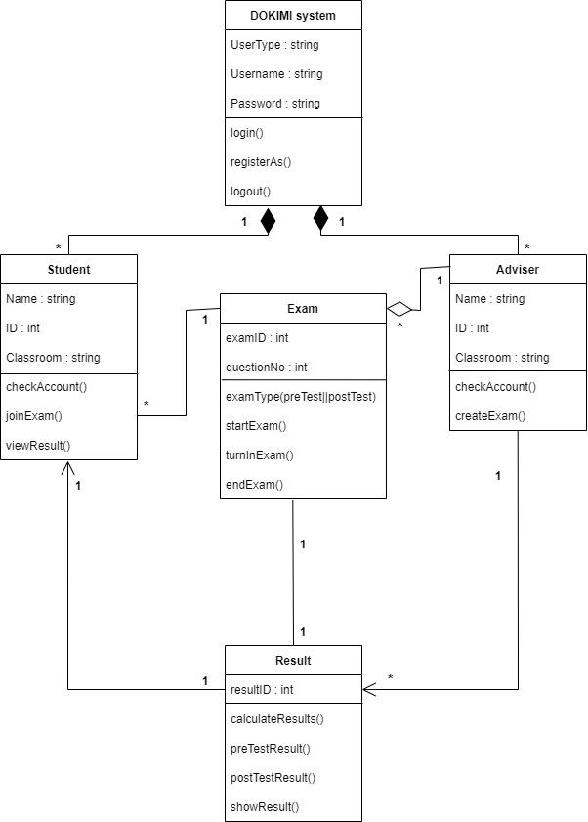

**Figure 13. Class Diagram for DOKIMI**

Figure 13 shows the Class Diagram where researchers will follow a structure layout for Dokimi. This will help the researchers maintain a balanced workflow in which they will see the goal of what they should achieve.

*3.5.5. Entity Relationship Diagram (ERD)*

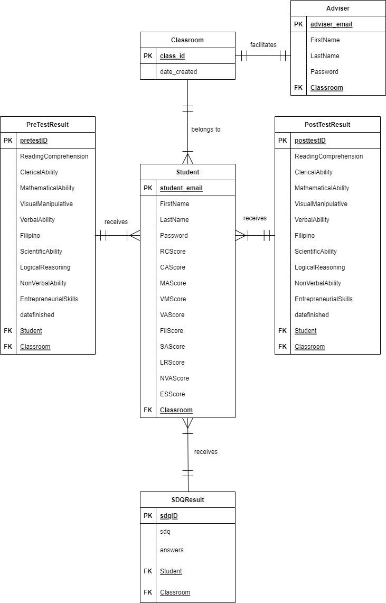

**Figure 14. Entity Relationship Diagram (ERD) for DOKIMI**

Figure 14 shows the Entity Relationship Diagram for Dokimi. Here, Advisers strictly belong to only one Class, and a Class consists of one or many Students and Students belong to only one class. After the Students answer the Student Descriptive Questionnaire (SDQ), Part I (Pre-test), and Part II (Post-Test), Students will receive their corresponding scores.

*3.5.6 Data Context Diagram*

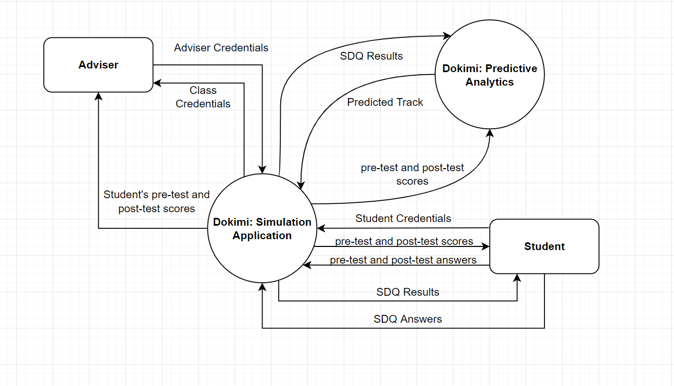

**Figure 15. Data Context Diagram for DOKIMI**

Figure 15 shows the Data Context Diagram where researchers will assert that the data flow of Dokimi will be strictly based on the given diagram above for security of the user’s data, since NCAE Examinations whether it is for review or official examination, sensitive data is always present.

**4. RESULTS, ANALYSIS, AND DISCUSSION**

This chapter shows the result of the surveys, the analysis of the researchers, and also the prototype of the research. The finding results of the survey are analyzed and discussed to properly display the necessary information for this project.

**4.1 Respondent Profile**

There are 33 respondents in this study that includes a diverse group of students who have taken the NCAE Exam before. The survey was completed by college students from various high schools and universities. Because some of the respondents did not want to supply the requested information, their names and gender were not included during the profiling process.

**4.2 Research Survey**

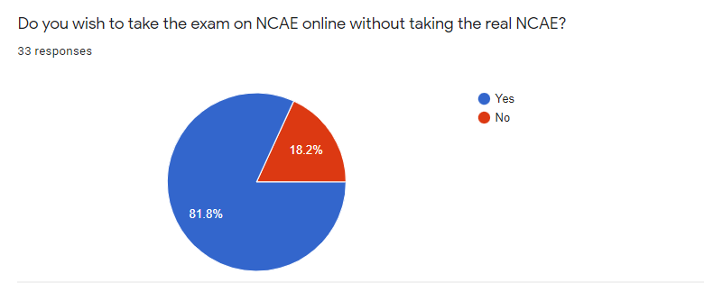

**Figure 16. Question No. 1 - Do you wish to take the exam on NCAE online without taking the real NCAE?**

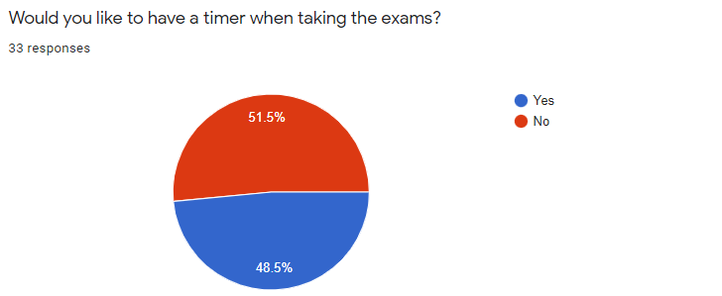

**Figure 17. Question No. 2 - Would you like to have a timer when taking the exams?**

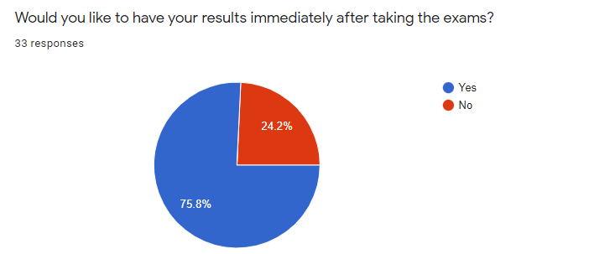

**Figure 18. Question No. 3 - Would you like to have your results immediately after taking the exams?**

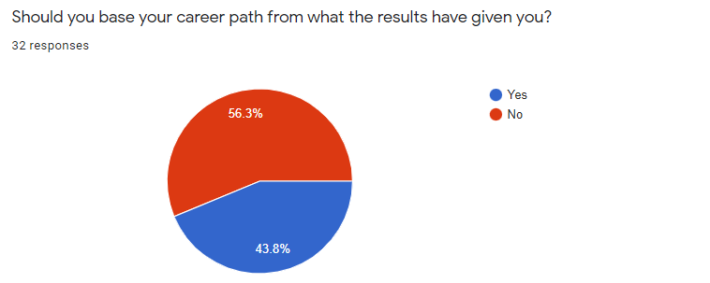

**Figure 19. Question No. 4 - Should you base your career path from what the results have given you?**

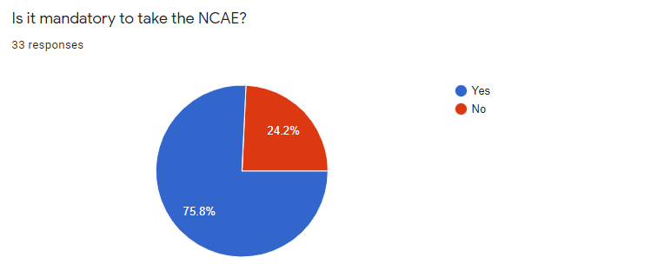

**Figure 20. Question No. 5 - Is it mandatory to take the NCAE?**

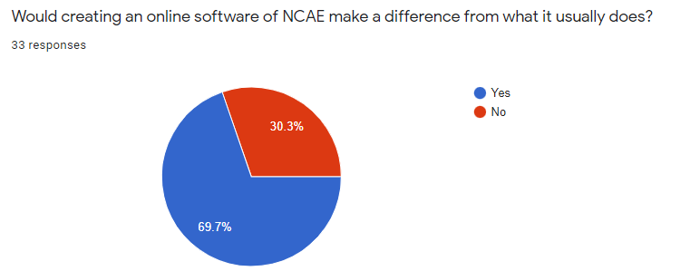

**Figure 21. Question No. 6 - Would creating an online software of NCAE make a difference from what it usually does?**

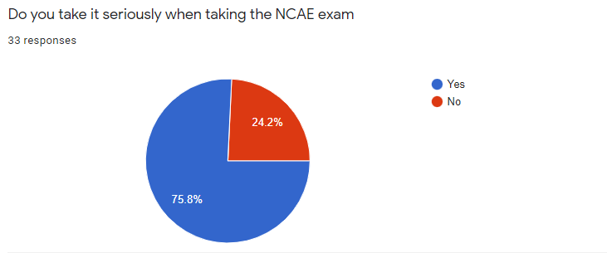

**Figure 22. Question No. 7 - Do you take it seriously when taking the NCAE exam?**

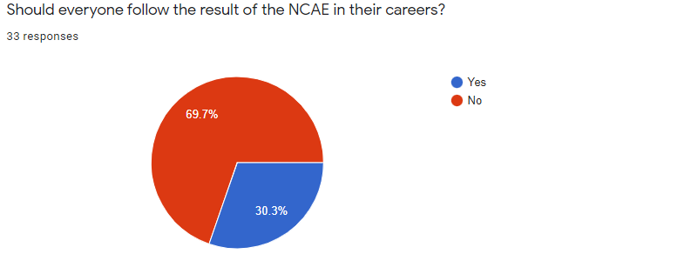

**Figure 23. Question No. 8 -Should everyone follow the result of the NCAE in their careers?**

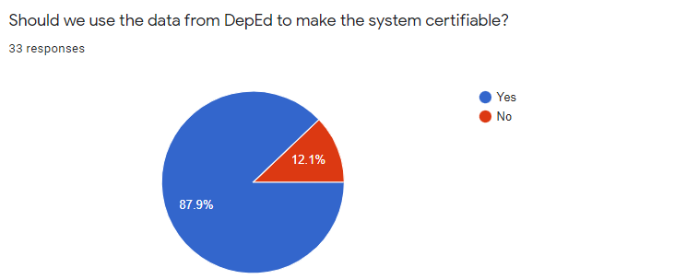

**Figure 24. Question No. 9 - Should we use the data from the DepEd to make the system certifiable?**

One of the characteristics of all respondents who took the survey is that they have already taken the NCAE Examination. Majority of the respondents strongly agreed that Grade 9 Students should take the NCAE Reviewer first based on (Fig. 16.) that resulted in 81.8% YES, 18.2% NO. However, the respondents wanted not to have a time limit during the NCAE Review based on (Fig 17.) with a score of 51.5% YES, 48.5% NO. Majority of the respondents wanted the results to be displayed immediately after taking the exam with a score of 75.8% YES, 24.2% NO based on (Fig. 18.). There was a clash on the results in (Fig. 19.) with a score of 56.3% NO, 43.8% YES where the respondents do not want to base their career path based on the results given. Majority of the respondents asserted that it is mandatory to take the NCAE as per the new curriculum with a score of 75.8% YES, 24.2% NO in (Fig. 20.). In (Fig. 21.), the score is 69.7% YES, 30.3% NO in favor of the creation of an online NCAE Reviewer will make a difference from the conventional method practiced today. The respondents asserted that they took the NCAE seriously with a score of 75.8% YES, 24.2% NO in (Fig. 22.), but the respondents in (Fig. 23.) do not want to follow the NCAE Results, and the question has a score of 69.7% NO, 30.3% YES. In (Fig. 14.), it has a score of 87.9% YES, 12.1% NO which means that the researchers of this study should base the data from the Department of Education (DepEd), so that the system will be certifiable, and legitimate.

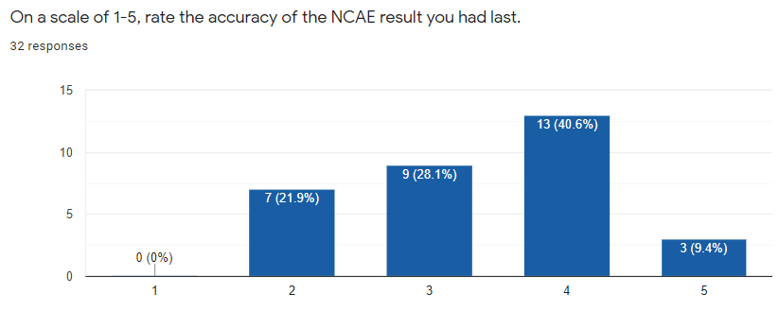

**Figure 25. Question No. 10 - On a scale of 1-5, rate the accuracy of the NCAE result you had last.**

Finally, the last question in (Fig. 25.), 40.6% (13 respondents) would say that the NCAE result they took before was very accurate (4), which is on the lead based on the said figure. This means that most of the time, the student’s NCAE performance reflects on the specific results such as their future profession. However, the 28.1% (9 respondents) who chose a fairly accurate (3), and 21.9% (7 respondents) who chose a less accurate (2) NCAE result would mean that there are certain areas on the results where the respondents won’t believe that based on their NCAE performance would reflect on the specific results such as their future profession. The minority, 9.4% (3 respondents) would say that they are confident their NCAE performance is perfectly accurate (5) with the NCAE results.

In conclusion, most of the students would take the actual or review of the NCAE Examination, but the challenges during and after the examination is strongly present as per the survey questions. In terms of test results, a lot of respondents do not want to base their future profession based on the NCAE performance, and this is the recurring pain points in taking an actual or review NCAE Examination, because students may take the examination out of mere compliance, and possible rewards that are irrelevant to the examination. Many respondents weren’t in favor of having a time limit in the NCAE review, but retaining the time limit will be a good exercise for students where they can hone their skills in answering the examination on or before the time runs out. Fortunately, most of the respondents wanted a modern method of answering the NCAE Examination by utilizing a software that will serve as an avenue in answering the examination. For the integrity factor, 8 out of 33 respondents based on the survey do not take the NCAE seriously. This is also a recurring problem in many schools, and universities where some of the Grade 9 students who answered the NCAE Examination tend to violate the rules and regulations, and/or answer the examination without reading the questions. Lastly, in terms of accuracy, not all respondents were pleased regarding to their last NCAE Result, and this presents a challenge to this study where the researchers plans to collect data from DepEd, or to the Junior High School Department of Cebu Institute of Technology - University (CIT - U) to elevate the accuracy of our study.

**4.3 System Prototype**

This section is the step-by-step walkthrough of the study’s initial prototype. The preceding figures; (Fig. 16. to Fig. 25.) served as a guide for the researchers to initially design a system that will be unique to other generic software based on the Review of Related Software (Section 2) of the study to provide a high quality, and a worthwhile experience in answering the NCAE Examination.

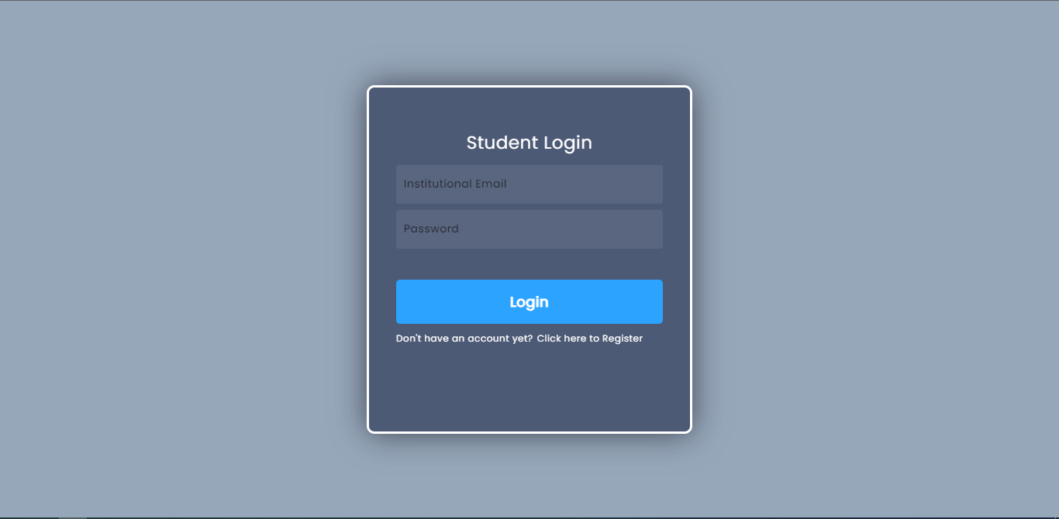

**Figure 26. Student Login Page**

This is the Student Login Page, where the user is directed when he/she opens the website. When the user doesn’t have an account yet, the user can click the option, ‘Click here to Register’.

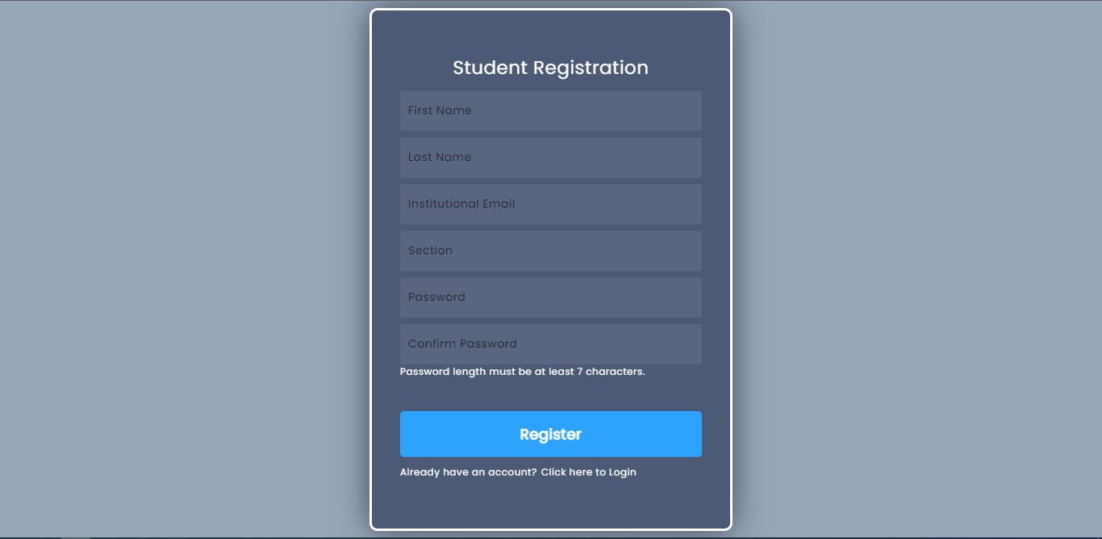

**Figure 27. Student Registration Page**

This is the registration page for students. The page asks for the student’s first name, last name, institutional email, and password. The section serves like an invitation code which will be given by the advisers.

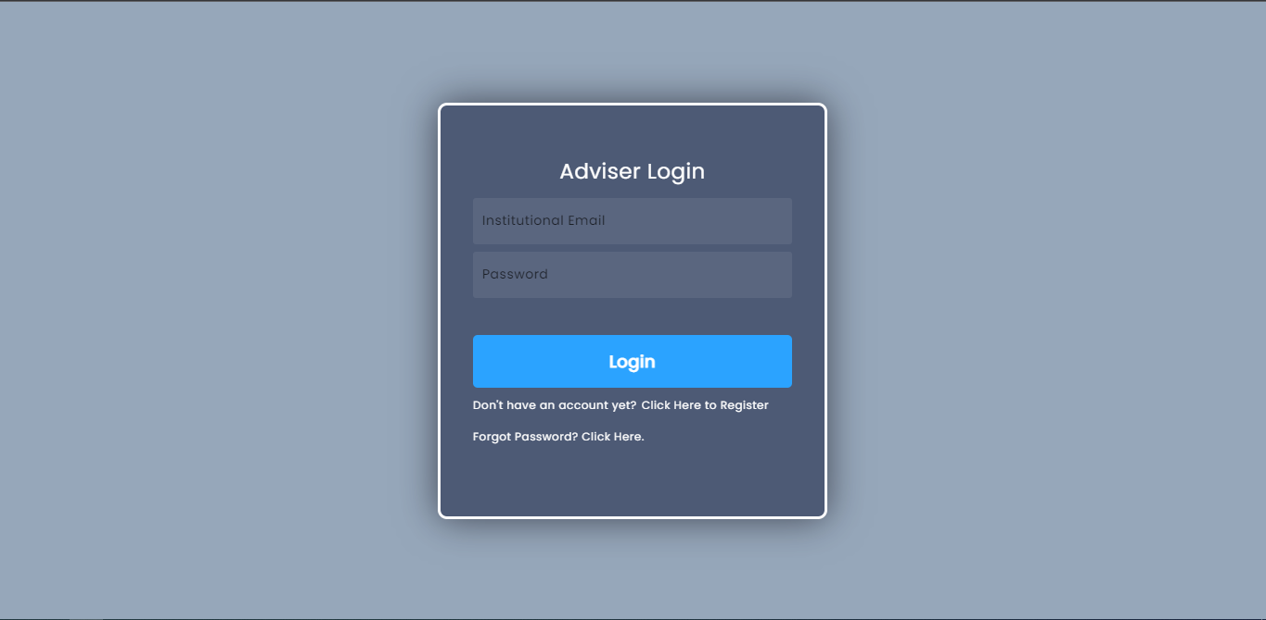

**Figure 28. Adviser Login Page**

This is the Adviser Login Page, where the user is directed when he/she opens the website. When the user doesn’t have an account yet, the user can click the option, ‘Click here to Register’.

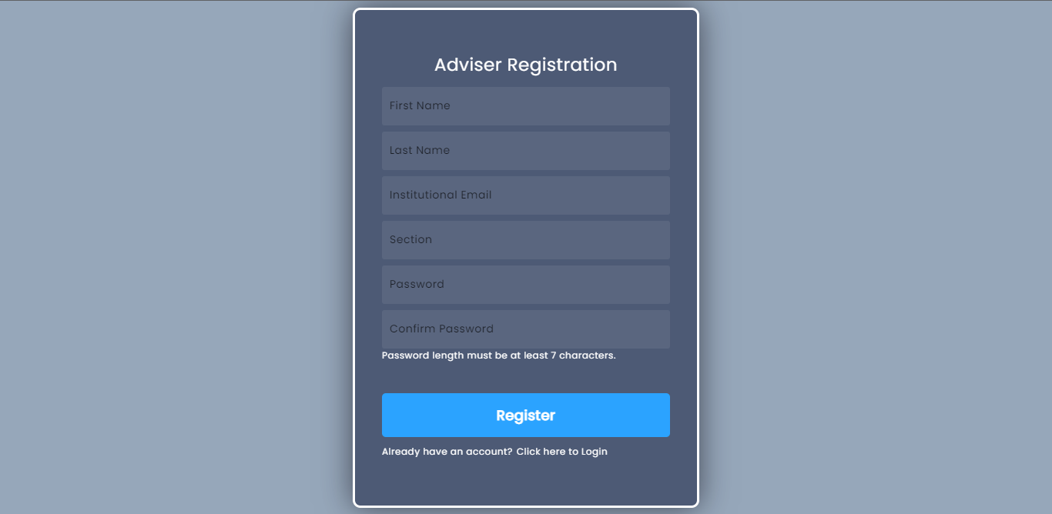

**Figure 29. Teacher Registration Page**

This is the registration page for teachers. The system will ask about the teacher’s first name, last name, institutional email, password, and section.

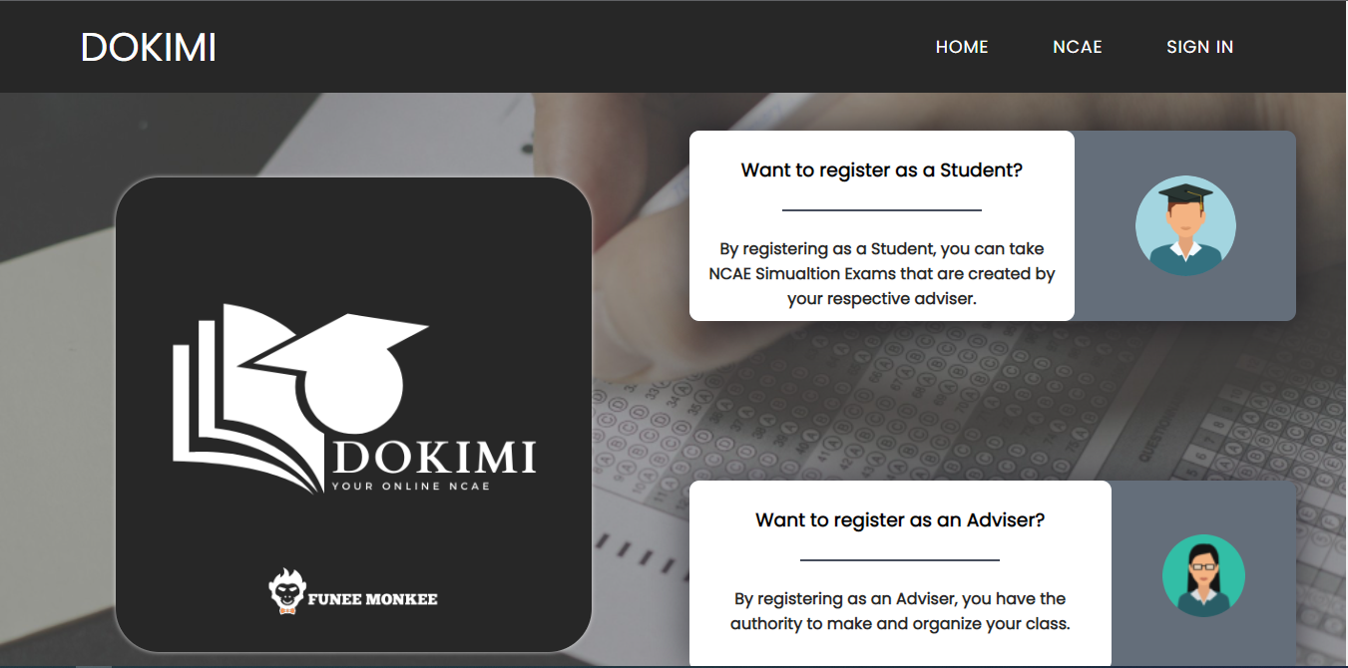

**Figure 30. Landing Page**

The Landing Page of Dokimi will contain general information of all classes taking up the Pre-Test and Post-Test NCAE Examination. Here, students will search for their respective class and join using the invitation code (Class Code) given by their respective adviser.

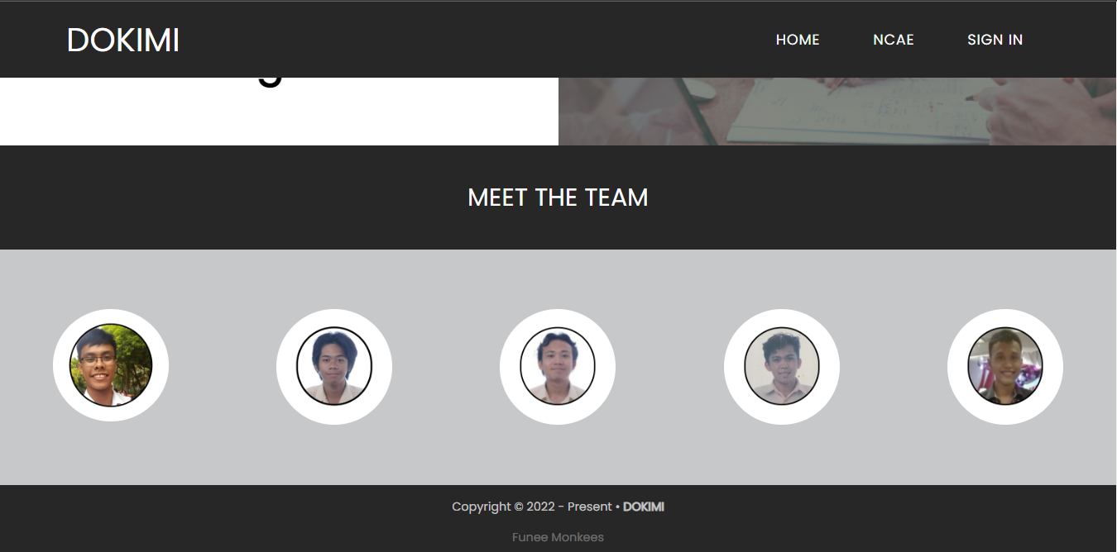

**Figure 31. About Us**

The About Us Page is where we provide information about our website and what it can deliver. It also shows our team-the developers.

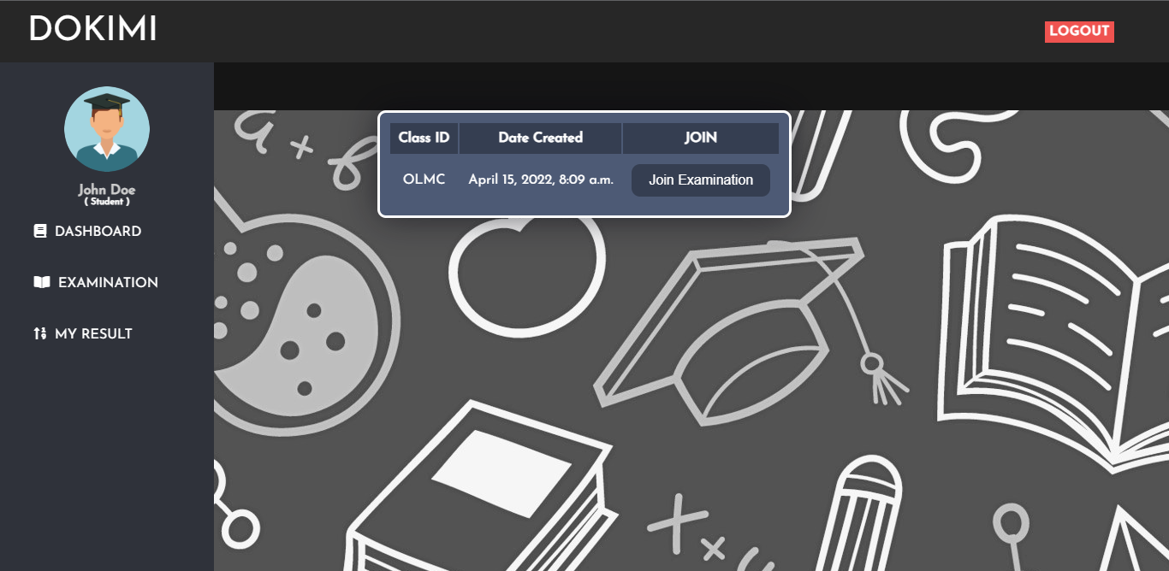

**Figure 32. Student Page**

The Student Page is where users that are registered as students can see their profile. The student can also see the results of their exam and will be redirected to that page by clicking the link on this page.

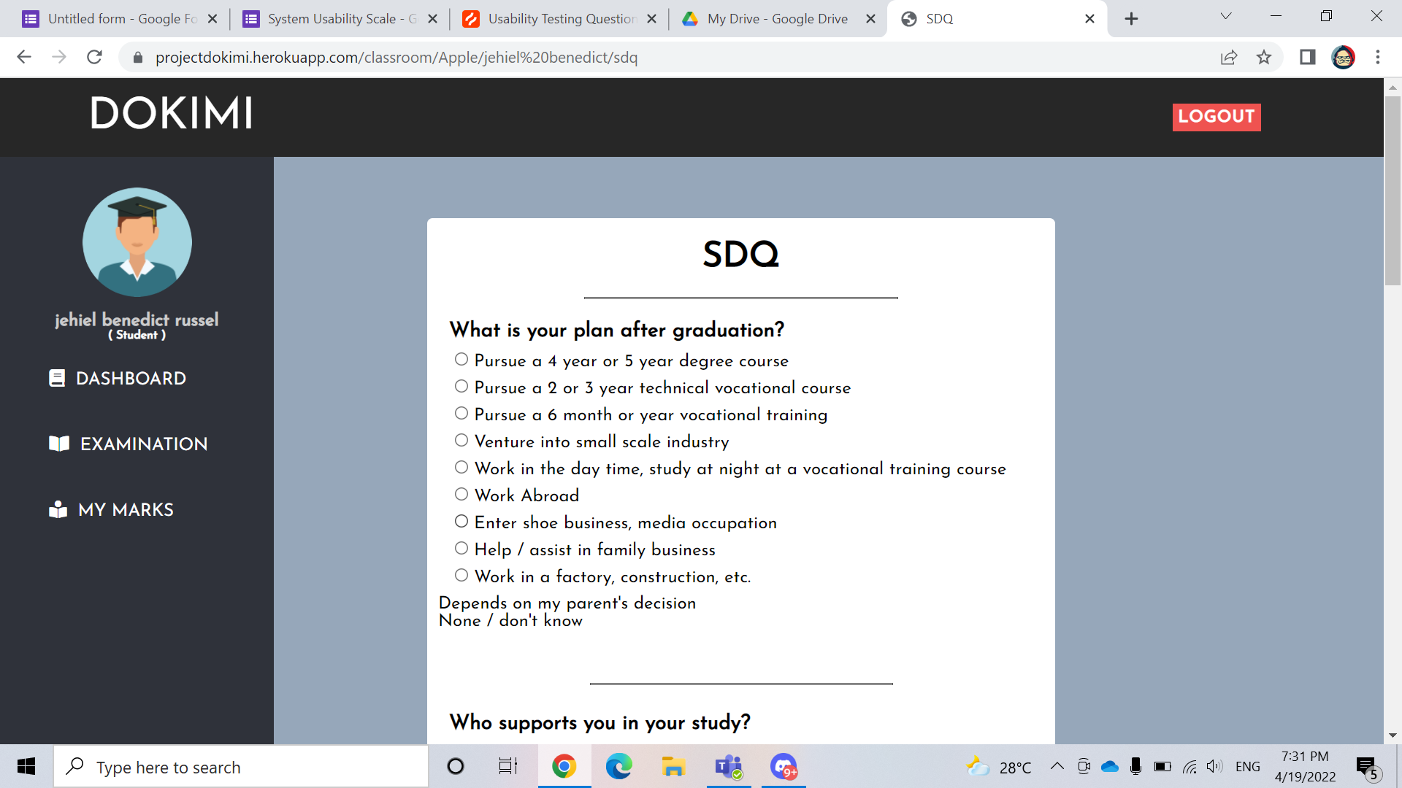

**Figure 33. Exam Proper - Student Descriptive Questionnaire (SDQ)**

Upon joining the examination within their respective class. The first section of the examination will be the Student Descriptive Questionnaire (SDQ) where students will answer their personal background. There are no right or wrong answers in taking SDQ, but these questions must be answered with honesty.

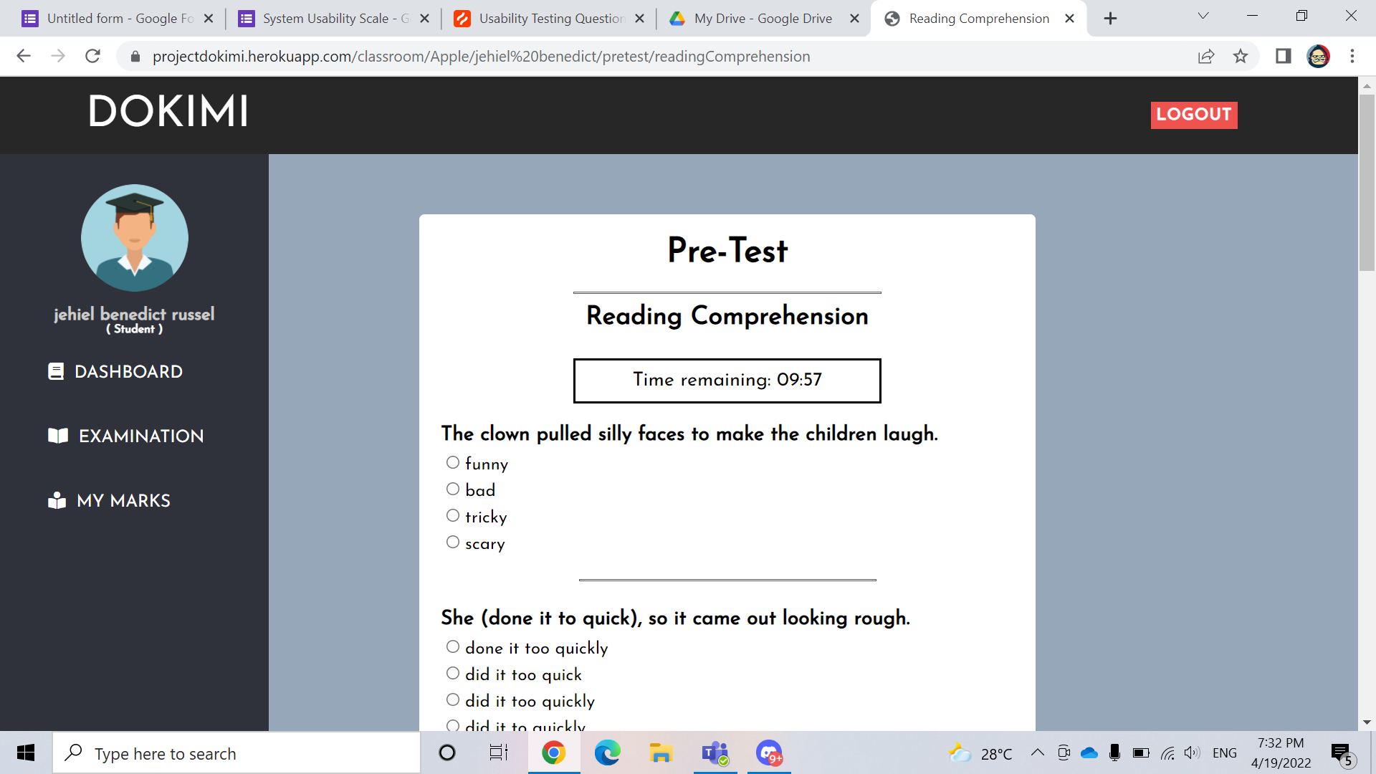

**Figure 34. Exam Proper - Pre-Test (Part I)**

The Pre-Test will be Part I of the NCAE Examination where the students will be given 1 hour per section in answering the examination. After the Part I (Pre-test), the student’s score result will be recorded on the Result Page. Students may only take the Part I (Pre-test) once, and it will be locked after answering.

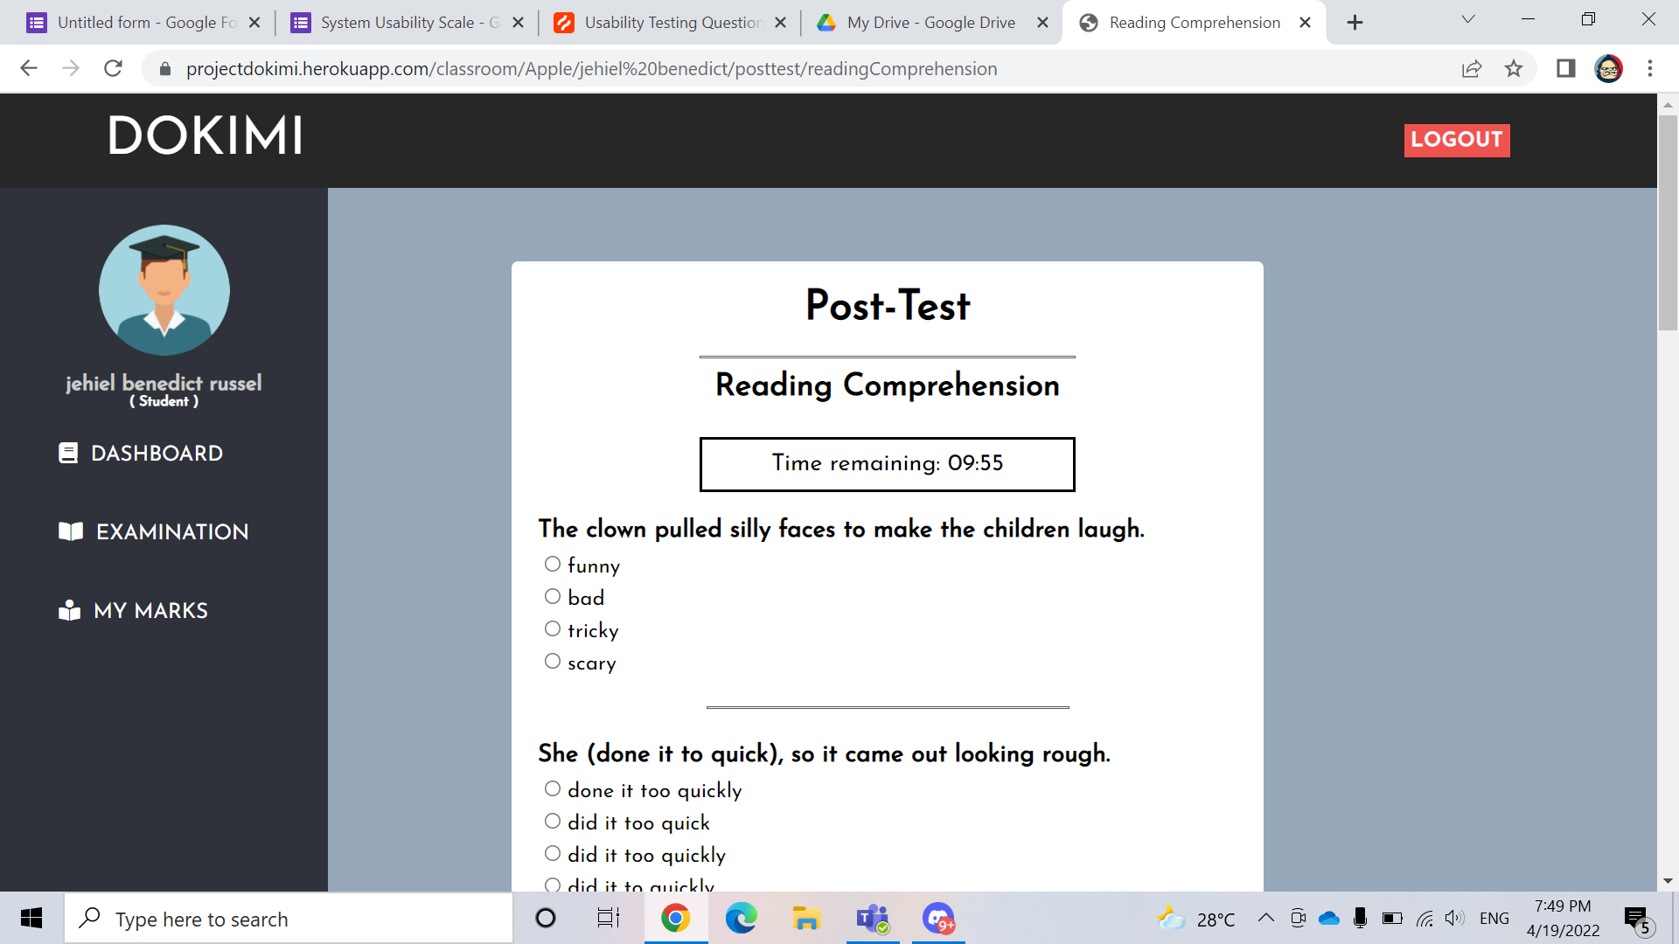

**Figure 35. Exam Proper - Post-Test (Part II)**

The Post-Test will be Part II of the NCAE Examination where the students will be given 1 hour per section in answering the examination. After the Part II (Post-test), the student’s score result will be recorded on the Result Page. Part II (Post-test) examination will be locked if Part I (Pre-test) is ongoing, and it will only be available once the advisers deem it to be accessible, and ready for answering the Part II (Post-test) examination.

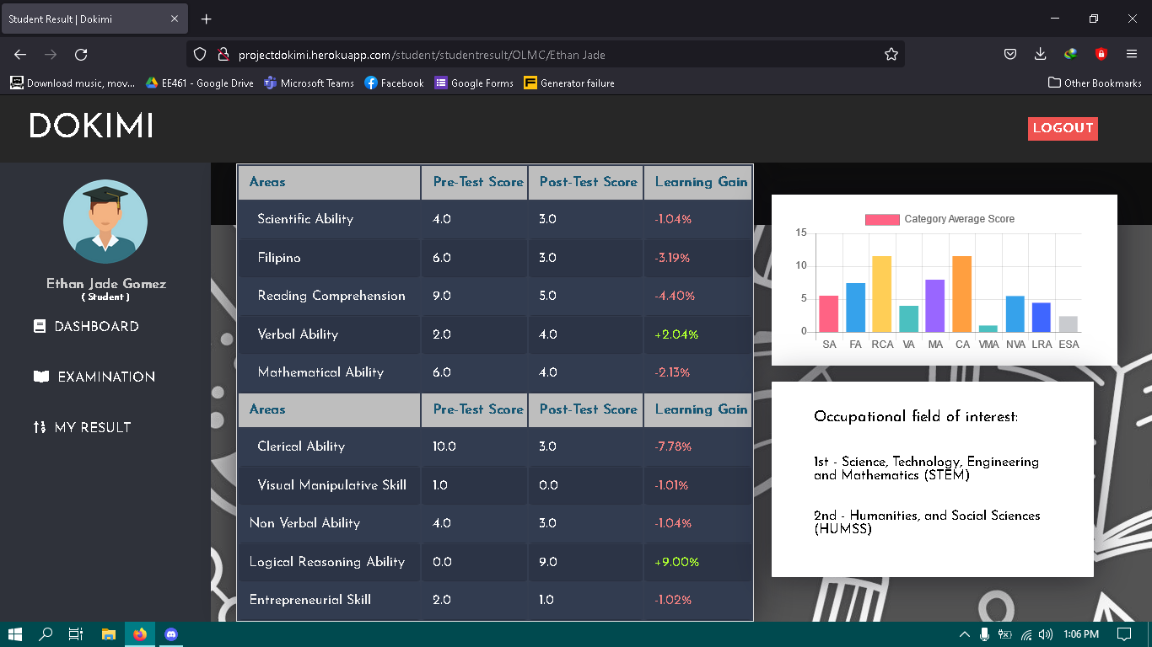

**Figure 36. Student Score Results Page**

This is the Result Page of the students that are taking the specific exam. They can view this page whenever by clicking the link in the Student Page.

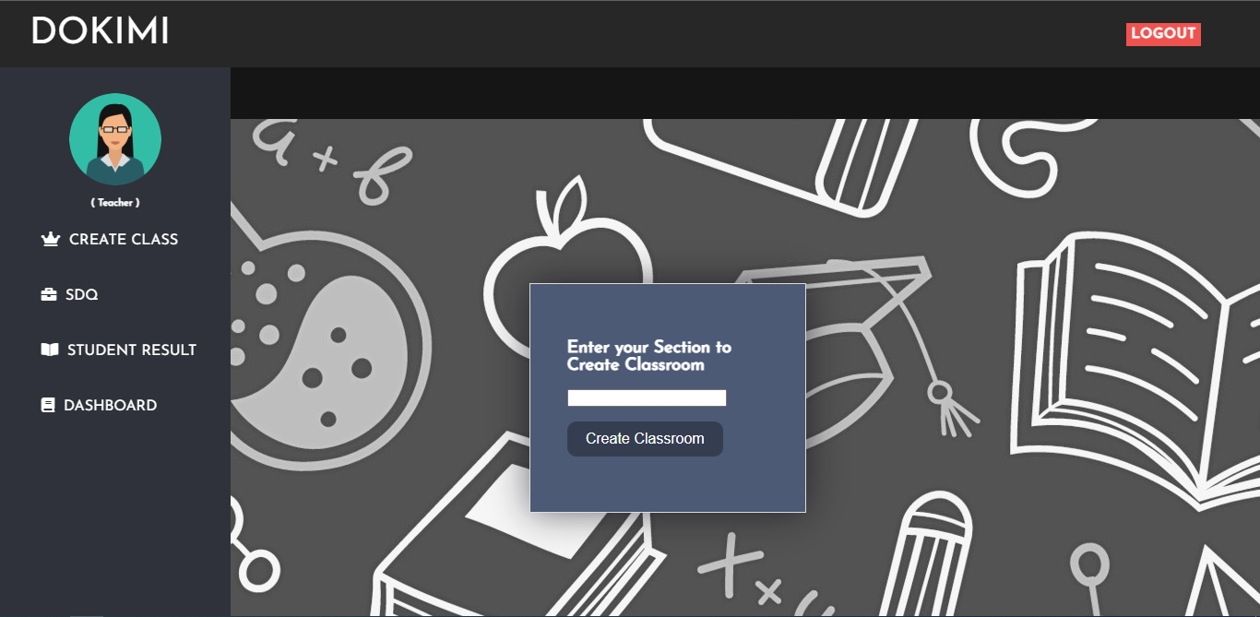

**Figure 37. Advisers Page**

This is the part of the adviser’s page where they can host an NCAE exam. The adviser must input the following: Section Code. The Section Code serves as the invitation code for the students that will take the exam.

**4.4. System Usability Scale**

Dokimi was deployed to production to be utilized for System Usability Testing by the researchers. The testing is part of Dokimi's post-development phase, in which respondents from the initial survey with the same demographics were given the chance to try out Dokimi for the first time, and at the end of the survey, they were given a survey and feedback form. An in-depth analysis on the “Student Results” will also be discussed in this section.

Llego (2014) in their article; 2019 National Career Assessment Examination (NCAE) reported that official NCAE scores are reported in Standard Scores (where the mean is 500 and standard deviation is 100, the highest scores are in the 700’s, and the lowest are in the 300’s) and Percentile Ranks (shows the test taker’s position among all the examinees. If the percentile rank scores 99+, it means that the examinee scored above the other 99% of other examinees.). In Dokimi’s setting, quasi-experimental, one-group pretest/post-test method was used to determine the learning gain of each students, and based on the average score of both pretest/post-test examination, Dokimi will draw conclusion on what Senior High School Strand a student will potentially belong.

Camara, J. S. (2018) reported that in their profiling of SHS Strands based on the NCAE aptitudes, STEM had the highest average in terms of Scientific Ability, Reading Comprehension, Mathematical Ability, and Verbal Ability. For GAS, Verbal Ability, Logical Reasoning, Clerical Ability, and Reading Comprehension had the highest average. HUMSS had the highest average for Reading Comprehension, Clerical Ability, Non-verbal Ability, and Verbal ability. ABM had the highest average for Reading Comprehension, Verbal Ability, Clerical Ability, Non-verbal ability, and Visual manipulative Skill. Lastly, for the TVL, Reading Comprehension, Mathematical Ability, Logical Reasoning, and Non-verbal Ability had the highest average despite being reported as one of the lowest average strand. So, based on the enumerated aptitudes per strand, this is where Dokimi will draw conclusions as to what strand the student will belong to, in order to fulfill one of Dokimi’s objectives where the system will provide baseline data for the students..

Class average normalized gain <g> was used to calculate for the learning gain where class average normalized gain <g> is defined as the average actual gain divided by the maximum possible gain where (G) is the actual gain and (%posttest) and (%pretest) are the final (%posttest) and initial (%pretest) class averages, and the angle bracket <...> indicate an average of the students taking the tests. 

Fig. Class average normalized gain equation

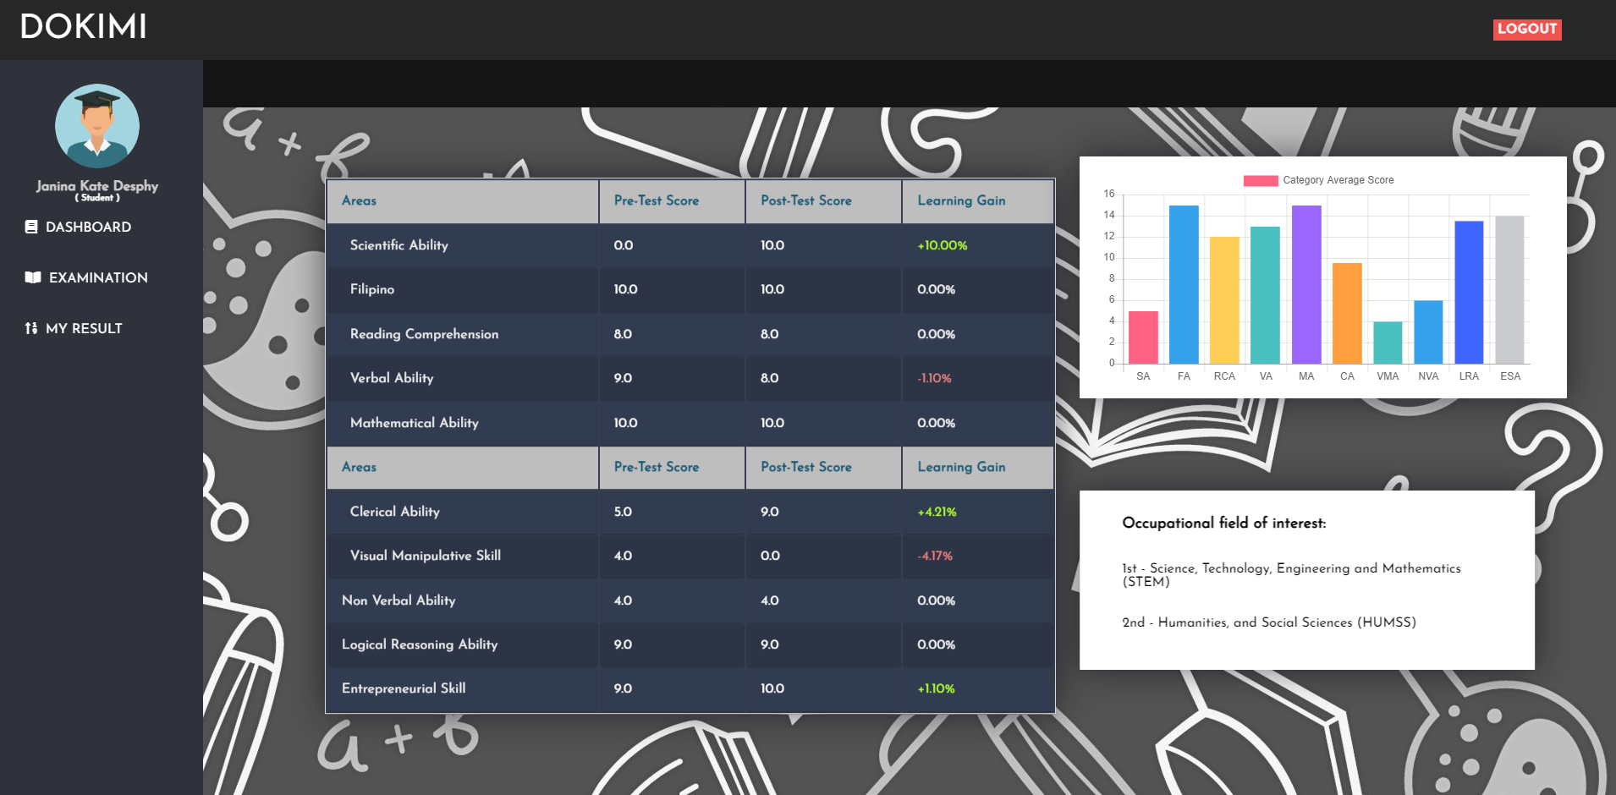

**Figure 38. Student Result Page taken from one of the respondents**

The figure above shows the in-depth analysis of the student’s pretest and post-test result where the pretest and post-test scores per aptitude (left), and the learning gain where scores with green color indicates an increase of learning gain, default white color if the pretest and post-test scores were maintained, and red color indicates a decrease of learning gain. Pretest and post-test scores were calculated through averaging, and the average pretest/post-test score will be tabulated on the graph (upper-right) represented as the Aptitudes (x-axis), and the average pretest/post-test scores (y-axis). The fields of interest (lower-right) indicates the potential SHS Strand of the student where the student will belong to a specific strand if certain aptitudes will have 70% or more on the average pretest/post-test score.

The survey results below are in-line with the respondents utilizing Dokimi for the first time, and rate their overall experiences while using Dokimi. There are 16 total respondents who answered our call to be a part of our System Usability Testing, and took our survey once the respondents were finished using Dokimi.

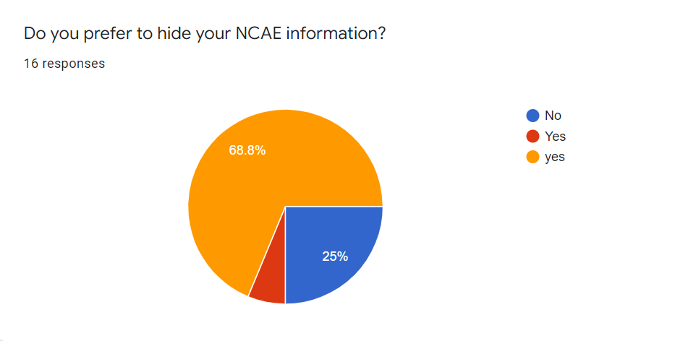

**Figure 39. Question 1**

For this question, there are 12 respondents who want to hide their NCAE Information while 4 respondents said no. This means that respondents wanted to keep information private, so the researchers reviewed the system again, and asserted that data leak and sharing of information was already prohibited based on the logic and architecture of Dokimi.

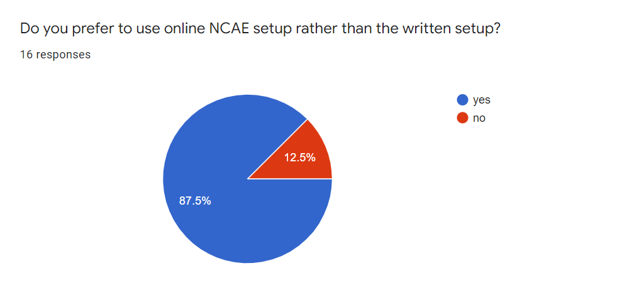

**Figure 40. Question 2**

There are 87.5% of respondents who wanted an online NCAE rather than the written setup where 12.5% of respondents wanted NCAE simulations to remain conventional. This means that most of the respondents wanted to shift the NCAE review phase to become technology-oriented. The disadvantages of using conventional methods is that when an examinee shaded an option in a wrong manner, the next 5 questions will be ignored, and it will jump after the said 5th question, and if the NCAE answer sheet is damaged, the examinee will be left behind if the examination is already onto the next aptitude while Dokimi, the modern method of NCAE simulation exam saves the instance where the student can still retake an aptitude in an event where problems will occur.

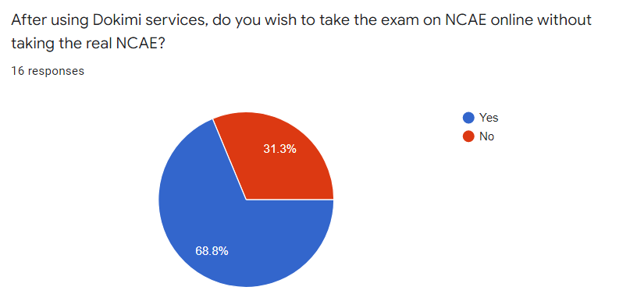

**Figure 41. Question 3**

There are 68.8% respondents wanted to take NCAE simulation examination like Dokimi to test their skills, and determine their initial skill levels through learning gain, and initial field of interest for SHS before taking the official NCAE examination, so that respondents who agreed wanted to compare their improvements, and potential SHS strand from Dokimi to the official NCAE examination. The 31.3% respondents who disagreed wanted to jumpstart on taking the official NCAE examination.

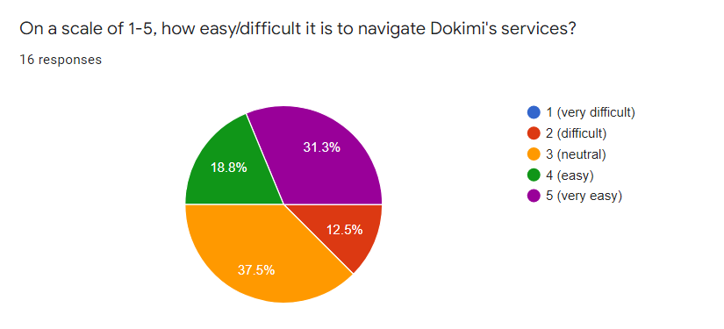

**Figure 42. Question 4**

This question suggests that most of the respondents had an easy time navigating the Dokimi website with only 12.5% of the respondents having difficulty on it.

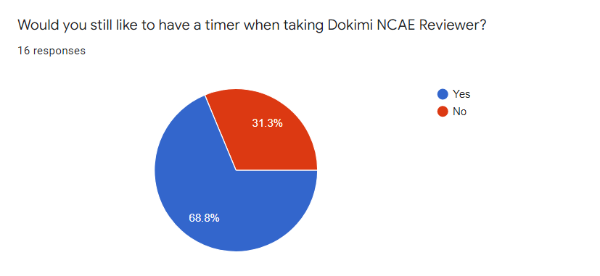

**Figure 43. Question 5**

There are 68.8% of respondents who wanted a timer when taking the exam. These suggest that they want pressure upon taking the exam to challenge them in answering. The 31.3% respondents do not want to feel pressured when taking the exam.

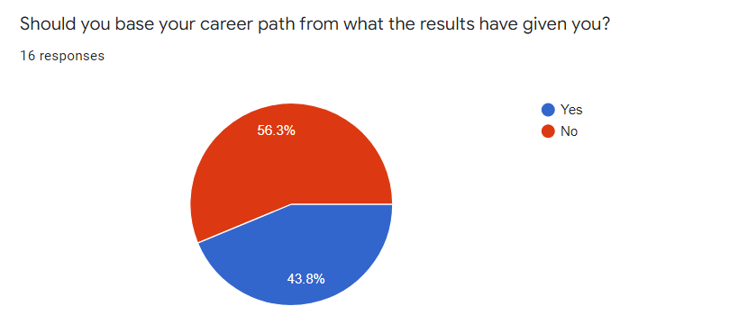

**Figure 44. Question 6**

There is almost a split of opinion in this question, 56.3% of respondents do not want their career path to be based on the results of the NCAE, suggesting that most students would rather pick on their own choices than being suggested for them. The 43.8% respondents based their career path on the results they’ve made on the exam.

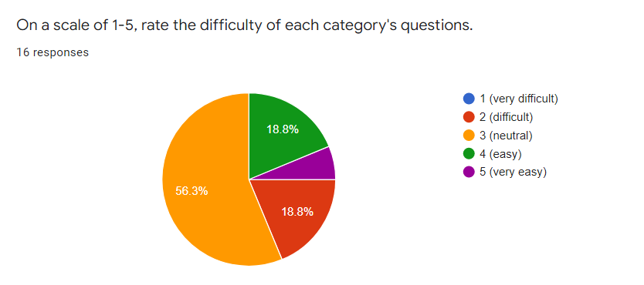

**Figure 45. Question 7**

There are 56.3% respondents who are ‘neutral’ in terms of the difficulty of the questions, and the same percentage for ‘easy’ and ‘difficult’ with 18.8% respondents and only a few for ‘very easy’. This suggests that the Dokimi questionnaire can either be difficult or easy depending on the knowledge of the student taking it.

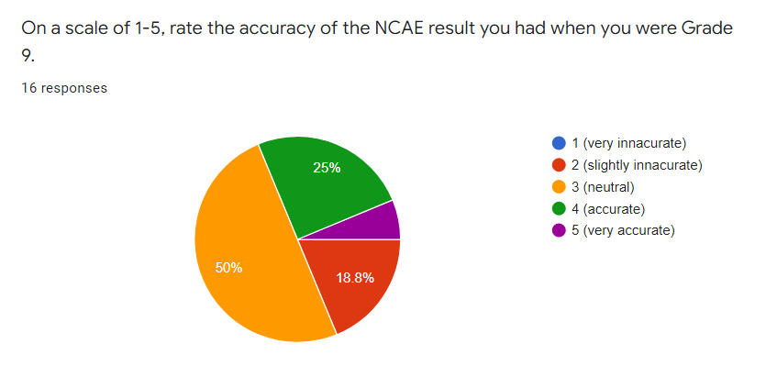

**Figure 46. Question 8**

50% of respondents answered that the NCAE results that they got were neutral when they were Grade 9, 25% answered that it is accurate, 18.8% respondents answered that the results are slightly inaccurate and 6.3% answered that it’s very accurate.

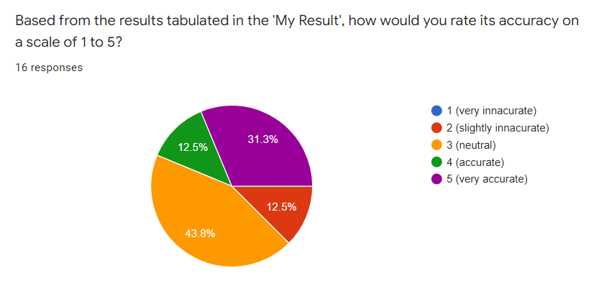

**Figure 47. Question 9**

43.8% of respondents answered that the results they got are neutral, 12.5% are both accurate and slightly inaccurate, and the rest of 31.3% answered that it’s very accurate.

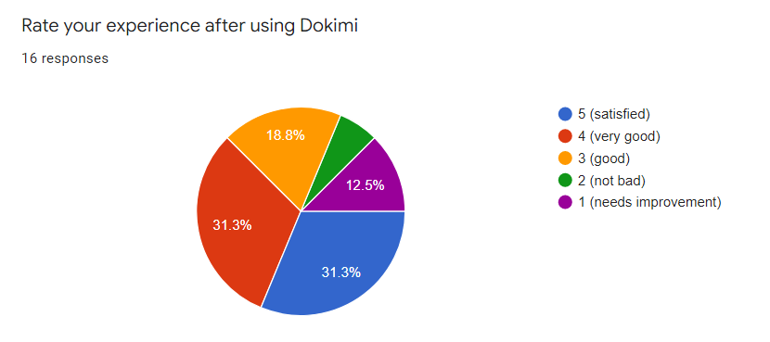

**Figure 48. Question 10**

As a developer, it is important for us to know the user’s opinion about our project, so we asked them to rate their experience after using the system, to know if it needs a lot of improvement or not. So we gathered that 31.3% of the respondents are satisfied with our project, the other 31.3% answered that it’s very good, 18.8% said it’s good enough, 12.5% said that it needs improvement, and the final 6.3% said that it’s not bad.

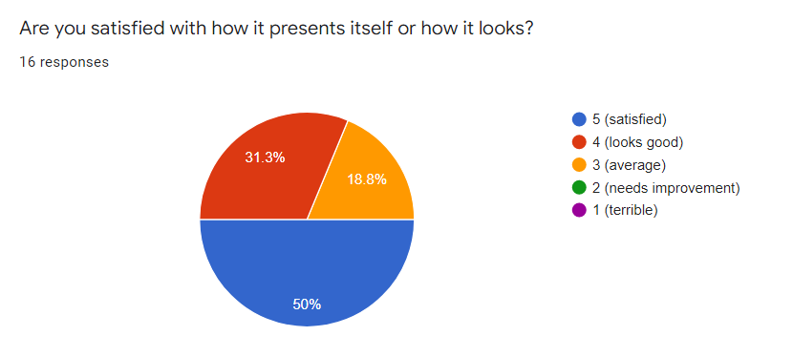

**Figure 49. Question 11**

This question focuses more on the UI side, with 50% of the respondents saying that the appearance of the website is pleasant and that they are satisfied. 31.3% said that it looks good and 18.8% says it’s average.

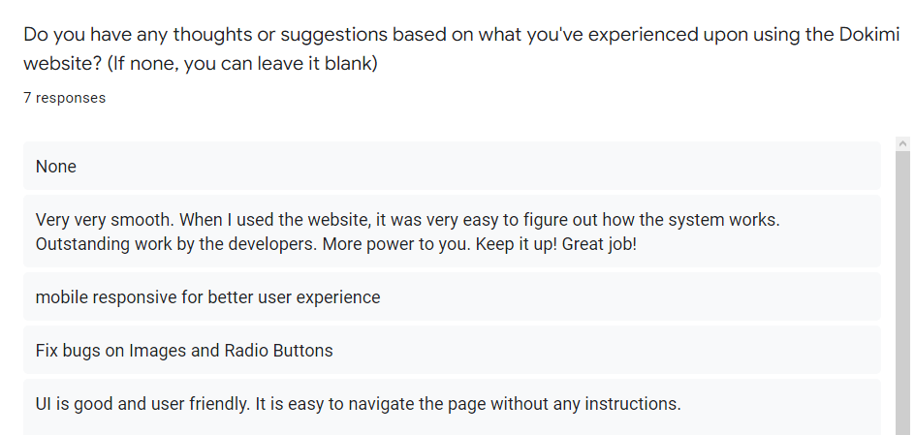

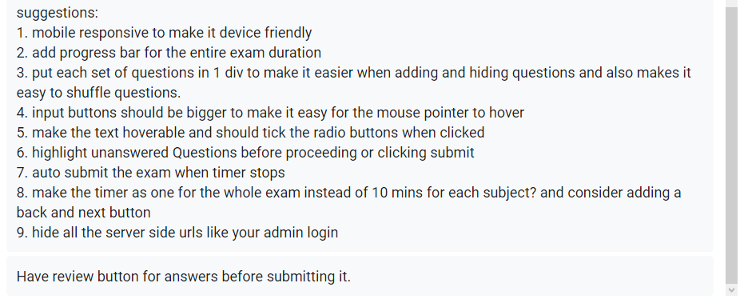

**Figure 50. Question 12**

Above shows the following suggestions of our respondents, with only 7 responses since this part is optional to fill up.

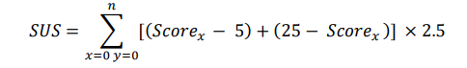

**Equation 1. Formula for the System Usability Score**

The equation above is the System Usability Score where it will gauge the overall performance of Dokimi based on the questions in Likert Scale answered by the respondents. With the help of the SUS formula, the sum of odd number questions was subtracted by 5 added by 25 minus the sum of even number questions multiplied by 2.5. The highest SUS Score is 67.5 with twice the occurrence, the lowest SUS Score is 52.5, and the SUS Score with the most common occurrence is 60. This means that the System Usability Testing was successful, but there was a need for further improvements during the testing phase (where some respondents reported UI/UX and functionality issues, but the issues reported by the respondents were addressed during the testing phase after the said respondents submitted their survey and feedback form).

**5 CONCLUSION AND RECOMMENDATION**

This is the conclusion and recommendation section of this study where the results, analysis and discussions’ findings were being observed by the researchers. There are two conclusions of this project; Adviser and Student. The Adviser section is mainly on the effectiveness of formulating questions within the system, and the Student section is mainly on answering the questions given by the Adviser, and the student results.

**5.1. Adviser**

Respondent E in the comments/suggestions quoted “UI is good and user friendly. It is easy to navigate the page without any instructions``, and Respondent B quoted “Very very smooth. When I used the website, it was very easy to figure out how the system works. Outstanding work by the developers. More power to you. Keep it up! Good job!” indicates that the addition of classroom, and formulating questions per aptitude in Dokimi is much simpler, and as effective as the questions formulated in the NCAE Reviewer Book. This will create an opportunity for Dokimi to be deployed in-premise specifically on review centers, libraries, and schools.

**5.2. Student**

Based on the first question of the survey, 87.5% respondents wanted to have an online NCAE simulation exam, making Dokimi more valuable in the future, Opinions from respondents were divided whether the accuracy on the NCAE is more accurate than Dokimi, but 31.3% respondents were confident that Dokimi is accurate (based on the choice 5(very accurate)), while the question of accuracy pertaining to NCAE doesn’t have a 5(very accurate) review. This makes Dokimi a better avenue than the conventional method of conducting the NCAE simulation exam in terms of providing baseline data for the students.

**5.3. Dokimi Technical Factor**

As far as Dokimi’s technical factor is concerned (UI/UX Design, and functionality), most of the respondents were able to use Dokimi without major problems, and are glad to use its services where 50% respondents were satisfied in the UI/UX, while 31.3% respondents rated that it looks good, and there was a split review rating of 31.3% respondents said that they are 5(satisfied) and 4(very good).

**5.4. Recommendation**

Some respondents reported that Dokimi still has software inconsistencies as per the respondents suggestion, and with the minority respondents stated that Dokimi still has to improve more, but most of their issues raised were resolved during the System Usability Testing. The following recommendations will help future Grade 9 NCAE Examinees to reassess their skillset, and determine their potential SHS Strand through Dokimi are:

* In-premise deployment to review centers, libraries, and schools,
* continuous assessment of students through Dokimi to improve NCAE integrity (to prevent cheating, and abuse), and
* adviser-student counseling after the student answered the NCAE simulation exam through Dokimi.

**6 REFERENCES**

[1] Flordeliza P. Ferrer. 2017. Correlation Of Stem Students’ Performance In The National Career Assessment Examination And Academic Subjects. <https://pdfs.semanticscholar.org/18a1/7f14d6cabbd02dd8eff77523687082ebdd03.pdf>

[2] Ermila D. Cardinas. National Career Assessment Examination Result, Career Pathway Choices, and Career Guidance Program Implementation. Bohol Island State University, Main Campus, Tagbilaran City, Bohol, Philippines.

<https://www.al-kindipublisher.com/index.php/jweep/article/view/1609/1335>

[3] Denis Abao Tan. 2018. Students’ Academic Performance, Aptitude and Occupational Interest in the National Career Assessment Examination. Faculty, College of Education, Central Mindanao University, University Town, Musuan, 8710 Bukidnon, Philippines. <https://www.researchgate.net/profile/Denis-Tan/publication/328965789_STUDENTS'_ACADEMIC_PERFORMANCE_APTITUDE_AND_OCCUPATIONAL_INTEREST_IN_THE_NATIONAL_CAREER_ASSESSMENT_EXAMINATION/links/5beda267299bf1124fd5cae0/STUDENTS-ACADEMIC-PERFORMANCE-APTITUDE-AND-OCCUPATIONAL-INTEREST-IN-THE-NATIONAL-CAREER-ASSESSMENT-EXAMINATION.pdf>

[3] Synap - Online Exam & Study Platform. <https://synap.ac/>

[4]TestGorilla - Pre-Employment Screening Tests and Assessments. [https://www.testgorilla.com/](https://www.testgorilla.com/?utm_source=capterra&utm_medium=ppc&utm_campaign=TestGorilla&utm_term=exam&utm_channel=GetApp)

[5] FlexiQuiz - Powerful online test and quiz maker. <https://www.flexiquiz.com/>

[6] YouTestMe - The Best Training and Knowledge Examination Software. <https://www.youtestme.com/>

[7] Khan Academy. <https://www.khanacademy.org/>

[8] Fresherslive. <https://www.fresherslive.com/>

[9] ClassMarker - The Best Quiz Maker for Business & Education. <https://www.classmarker.com/>

[10] QuestBase. <https://questbase.com/home-questbase/>

[11] College Entrance Exams Prep - VITEEE NIFT JNUCEE. <https://play.google.com/store/apps/details?id=com.youth4work.College_Entrance_Examination&hl=en&gl=US>

[12] USATestprep - Standards-Aligned Practice Tools for ELA, Math, Science, and Social Studies. <https://www.usatestprep.com/>

[13] Camara, J. S. (2018). Correlates of Self-efficacy, Learning Style and Aptitude Across Strand of Senior High School students in San Jacinto National High School. San Jacinto National high School, San Jacinto, Pang. PARESSU, Inc., San Jacinto, Pang. <https://www.researchgate.net/publication/340247732_Correlates_of_Self-efficacy_Learning_Style_and_Aptitude_Across_Strand_of_Senior_High_School_students_in_San_Jacinto_National_High_School>

[14] Gonzales, E. T. et al. (2020). Aptitude, Occupational Fields of Interest and Academic Performance of Stem Students. Sorsogon State College, Sorsogon City Campus, Philippines. <https://ijesc.org/upload/217a1cb30287cfe815bc5529bd74d79f.Aptitude,%20Occupational%20Fields%20of%20Interest%20and%20Academic%20Performance%20of%20Stem%20Students.pdf>

**7 APPENDIX**

**Appendix A**

**Survey Questionnaire**

**Consent for Participation**

This survey is intended to collect data inputs from users who are going to take NCAE, specifically Grade 9 Students. Our purpose is to know their opinion of the NCAE if they are willing to participate, taking it seriously, and know what’s at stake - by doing so, we can enhance and make solutions based on what we gather.

By continuing, you have:

1. Accepted to participate in this survey;
2. Understood the purpose of the survey;
3. Understood that the answers are confidential; and
4. Your participation is voluntary and you can withdraw from the survey at any moment.

Thank you.

**I. NCAE Experience**

* *Do you wish to take the exam on NCAE without taking the real NCAE?*
  + *Yes*
  + *No*
* *Would you like to have a timer when taking the exams?*
  + *Yes*
  + *No*
* *Would you like to have your results immediately after taking the exams?*
  + *Yes*
  + *No*
* *Should you base your career path from what the results have given you?*
  + *Yes*
  + *No*
* *Is it mandatory to take the NCAE?*
  + *Yes*
  + *No*
* *Would creating an online software of NCAE make a difference from what it usually does?*
  + *Yes*
  + *No*
* *Do you take it seriously when taking the NCAE exam?*
  + *Yes*
  + *No*
* *Should we use the data from DepEd to make the system certifiable?*
  + *Yes*
  + *No*
* *Should everyone follow the result of the NCAE in their careers?*
  + *Yes*
  + *No*
* *On a scale of 1-5, rate the accuracy of the NCAE result you had last.*
  + *1*
  + *2*
  + *3*
  + *4*
  + *5*

The researchers would like to extend their utmost gratitude for your participation.

Stay safe and God Bless!

Regards,

Dokimi Team

**Appendix B**

**Survey Questionnaire**

**Consent for Participation**

This survey is intended to collect data inputs from users who are going to take NCAE, specifically Grade 9 Students. Our purpose is to know their opinion of the NCAE if they are willing to participate, taking it seriously, and know what’s at stake - by doing so, we can enhance and make solutions based on what we gather.

By continuing, you have:

1. Accepted to participate in this survey;
2. Understood the purpose of the survey;
3. Understood that the answers are confidential; and
4. Your participation is voluntary and you can withdraw from the survey at any moment.

Thank you.

**Dokimi Usability Testing Survey and Feedback Form**

Good day! We are the researchers of Dokimi from Cebu Institute of Technology University. Now that we've introduced you to Dokimi, and used our services, we would like to know your overall experiences while using Dokimi.

This is in compliance with our Capstone 2 Project. As per the Data Privacy Act of 2012, it is our responsibility to ensure that your data in using Dokimi, and answering the Usability Testing Survey and Feedback Form will remain safe and secure.

In order for Dokimi to flourish in the future, your honest feedback will be greatly appreciated.

**I. Dokimi Experience**

* *Do you prefer to hide your NCAE information?*
  + *Yes*
  + *No*
* *Do you prefer to use online NCAE setup rather than the written setup?*
  + *Yes*
  + *No*
* *After using Dokimi services, do you wish to take the exam on NCAE online without taking the real NCAE?* 
  + *Yes*
  + *No*
* *On a scale of 1-5, how easy/difficult is it to navigate Dokimi's services? (5 is the highest; 1 is the lowest)*
  + *1 (very difficult)*
  + *2 ( difficult)*
  + *3 (neutral)*
  + *4 (easy)*
  + *5 (very easy)*
* *Would you still like to have a timer when taking Dokimi NCAE Reviewer?* 
  + *Yes*
  + *No*
* *On a scale of 1-5, rate the difficulty of each category's questions. (5 is the highest; 1 is the lowest)*
  + *1 (very difficult)*
  + *2 ( difficult)*
  + *3 (neutral)*
  + *4 (easy)*
  + *5 (very easy)*
* *On a scale of 1-5, rate the accuracy of the NCAE result you had when you were in Grade 9.*
  + *1 (very inaccurate)*
  + *2 (slightly inaccurate)*
  + *3 (neutral)*
  + *4 (accurate)*
  + *5 (very accurate)*
* *Based on the results tabulated in the 'My Result', how would you rate its accuracy on a scale of 1 to 5?* 
  + *1 (very inaccurate)*
  + *2 (slightly inaccurate)*
  + *3 (neutral)*
  + *4 (accurate)*
  + *5 (very accurate)*
* *Rate your experience after using Dokimi (5 is the highest; 1 is the lowest)*
  + *1 (needs improvement)*
  + *2 (not bad)*
  + *3 (good)*
  + *4 (very good)*
  + *5 (satisfied)*
* *Are you satisfied with how it presents itself or how it looks? (5 is the highest; 1 is the lowest)*
  + *1 (terrible)*
  + *2 (needs improvement)*
  + *3 (average)*
  + *4 (looks good)*
  + *5 (satisfied)*
* *Do you have any thoughts or suggestions based on what you've experienced upon using the Dokimi website? (If none, you can leave it blank)*

The researchers would like to extend their utmost gratitude for your participation.

Stay safe and God Bless!

Regards,

Dokimi Team